Tab 1

PYTHON ARCADE — CA 2 PROJECT REPORT

PAGE 1 — COVER PAGE

PYTHON ARCADE

An Interactive Gaming Application Using Python
CA 2 PROJECT REPORT
Submitted By:
Kashish Bhargava
Roll No.: 05
Course: BCA Digital Business
Year: FY
Subject: Python
Faculty: Rashmi Subodh Chavan
University: Pillai University
Academic Year: 2026–27

PAGE 2 — INTRODUCTION

1. Introduction
Python Arcade is a desktop gaming application developed using Python and the Tkinter GUI library. The application combines multiple mini-games into one interactive arcade-style platform with a dark neon gaming interface.
The main purpose of this project is to demonstrate the practical application of Python programming concepts through an interactive and user-friendly application.
Python Arcade contains eight different games:
- Number Guess
- Rock Paper Scissors
- Python Quiz
- Math Challenge
- Word Guess
- Memory Challenge
- Number Sequence
- Higher or Lower
Along with the games, the application includes a player account system, XP system, levels, achievements, game statistics, player profiles, and a leaderboard.
The project demonstrates how basic Python concepts can be combined to create a complete desktop application.

2. Project Objectives
The main objectives of Python Arcade are:
- To develop an interactive application using Python.
- To apply Python programming concepts in a practical project.
- To create a graphical user interface using Tkinter.
- To provide multiple games within a single application.
- To implement an XP and level system.
- To create achievements based on player progress.
- To maintain player game statistics.
- To create a leaderboard based on player XP.
- To practice file handling using text files.
- To create a simple and user-friendly gaming experience.

3. Main Features
The major features of Python Arcade are:

Player Account System
Players can create an account and log in using their username and password.

Multiple Games
The application contains eight different games with different gameplay mechanics.

XP System
Players earn XP by successfully completing challenges and games.

Level System
The player's level increases as they collect more XP.

Achievements
Players can unlock achievements after reaching specific XP milestones.

Player Statistics
The profile page displays:
- Games Played
- Games Won
- Games Lost
- XP Earned
- Recently Played
- Player Rank
- Level
- Achievement progress

Leaderboard
Players can compare their XP with other registered players through the leaderboard.

Persistent Data
Player accounts and game statistics are stored in text files so that the information can be retained.

4. Technologies Used
Create a small table in Word:
Technology | Purpose
Python | Main programming language
Tkinter | Graphical User Interface
Random Module | Random number and game generation
Text Files | Storing player accounts and statistics
Python IDLE | Development and execution

5. Working of the Application
When the application starts, the player is presented with the login page. A new player can create an account using the Sign Up option.
After logging in, the player reaches the main Home page. The navigation bar provides access to the different sections of the application.
The Games section contains eight games. Each game has its own rules and Python logic.
Players can earn XP by answering questions correctly, winning challenges, or completing games. The accumulated XP is used to calculate the player's level and unlock achievements.
The Profile page displays the player's statistics and progress.
The Scores page contains the leaderboard, where players are ranked according to their XP.
The application stores account information and game statistics using text files, allowing the information to remain available between sessions.

6. Python Concepts Used
The following Python concepts were used in the project:
- Variables
- Constants
- Data types
- Input and output
- Conditional statements
- if, elif, and else
- for loops
- while loops
- Functions
- Lists
- Dictionaries
- Global variables
- Random number generation
- String operations
- File handling
- Tkinter widgets
- Button commands and event handling
- Functions with parameters
- Formatted strings

PAGE 3+ — CODE

7. Code
The Python Arcade application is developed using Python and Tkinter. The program is divided into different sections to manage the user interface, player accounts, statistics, navigation, and individual games.

Main sections of the code include:
- Application setup
- Player account system
- Login and Sign Up
- XP system
- Game statistics
- Navigation system
- Home page
- Games page
- Scores page
- Player Profile
- Achievements
- Number Guess
- Rock Paper Scissors
- Python Quiz
- Math Challenge
- Word Guess
- Memory Challenge
- Number Sequence
- Higher or Lower

Important Programming Features
Functions are used throughout the application to keep the code organized and reusable. Tkinter widgets such as Buttons, Labels, Entry fields, Frames, and Canvas elements are used to create the graphical interface.
Conditional statements are used to determine game results, validate user input, calculate scores, and unlock achievements.
Loops are used for repeated operations such as generating questions, checking player records, displaying options, and processing game rounds.
The random module is used in games where random values are required, such as Number Guess, Rock Paper Scissors, and Higher or Lower.
Text file handling is used to store player account information and game statistics.

What about the actual huge code?
Since your teacher specifically says "Code", I would recommend putting the actual main.py code after this explanation.
import tkinter as tk
import random

# ============================================================
# PYTHON ARCADE
# ============================================================

window = tk.Tk()
window.title("PYTHON ARCADE • Level Up Your Python")
window.geometry("1100x700")
window.resizable(False, False)
window.configure(bg="#03040B")
window.option_add("*Font", ("Segoe UI", 10))

# ============================================================
# COLORS
# ============================================================

BG = "#060712"
NAVY = "#090C1B"
PURPLE = "#8B5CF6"
PURPLE_LIGHT = "#B49CFF"
PINK = "#EC4899"
CYAN = "#22D3EE"
BLUE = "#3B82F6"
GREEN = "#34D399"
ORANGE = "#F59E0B"
WHITE = "#FFFFFF"
LIGHT = "#DDE3F5"
GREY = "#8993B2"
CARD = "#11162D"
CARD_BORDER = "#252B4A"

# ============================================================
# MAIN CANVAS
# ============================================================

canvas = tk.Canvas(
window,
width=1100,
height=700,
bg=BG,
highlightthickness=0,
bd=0
)

canvas.pack()

page_items = []
page_widgets = []

# ============================================================
# PLAYER ACCOUNTS
# ============================================================

ACCOUNT_FILE = "player_accounts.txt"

current_username = ""
player_xp = 0

def load_accounts():

accounts = []

try:

file = open(ACCOUNT_FILE, "r")

for line in file:

line = line.strip()

if line != "":

parts = line.split("|")

if len(parts) == 3:

username = parts[0]
password = parts[1]
xp = int(parts[2])

accounts.append(
[username, password, xp]
)

file.close()

except:

accounts = []

return accounts

def save_accounts(accounts):

file = open(ACCOUNT_FILE, "w")

for account in accounts:

username = account[0]
password = account[1]
xp = account[2]

file.write(
username + "|" +
password + "|" +
str(xp) + "\n"
)

file.close()

accounts = load_accounts()

def save_current_account():

global accounts

if current_username == "":
return

for account in accounts:

if account[0] == current_username:

account[2] = player_xp

save_accounts(accounts)

def close_arcade():

save_current_account()
window.destroy()

window.protocol(
"WM_DELETE_WINDOW",
close_arcade
)

# ============================================================
# GAME STATISTICS
# ============================================================

GAME_STATS_FILE = "game_statistics.txt"

game_statistics = {}

def load_game_statistics():

statistics = {}

try:

file = open(GAME_STATS_FILE, "r")

for line in file:

line = line.strip()

if line != "":

parts = line.split("|")

if len(parts) == 6:

username = parts[0]
games_played = int(parts[1])
games_won = int(parts[2])
games_lost = int(parts[3])
xp_earned = int(parts[4])
most_played = parts[5]

statistics[username] = [
games_played,
games_won,
games_lost,
xp_earned,
most_played
]

file.close()

except:

statistics = {}

return statistics

def save_game_statistics():

file = open(GAME_STATS_FILE, "w")

for username in game_statistics:

stats = game_statistics[username]

file.write(
username + "|" +
str(stats[0]) + "|" +
str(stats[1]) + "|" +
str(stats[2]) + "|" +
str(stats[3]) + "|" +
stats[4] + "\n"
)

file.close()

game_statistics = load_game_statistics()

# ============================================================
# GAME STAT FUNCTIONS
# ============================================================

def create_player_statistics(username):

if username not in game_statistics:

game_statistics[username] = [
0,
0,
0,
0,
"None"
]

save_game_statistics()

def record_game(game_name, won, xp):

global game_statistics

if current_username == "":
return

create_player_statistics(current_username)

stats = game_statistics[current_username]

# Games played

stats[0] += 1

# Games won / lost

if won:

stats[1] += 1

else:

stats[2] += 1

# XP earned

stats[3] += xp

# Most played game

stats[4] = game_name

save_game_statistics()

# ============================================================
# PAGE MANAGEMENT
# ============================================================

def clear_page():

global page_items, page_widgets

for item in page_items:

try:
canvas.delete(item)
except:
pass

page_items = []

for widget in page_widgets:

try:
widget.destroy()
except:
pass

page_widgets = []

def add_item(item):

page_items.append(item)
return item

def add_widget(widget):

page_widgets.append(widget)
return widget

# ============================================================
# BACKGROUND
# ============================================================

def draw_background():

canvas.delete("background")

canvas.create_rectangle(
0,
0,
1100,
700,
fill=BG,
outline="",
tags="background"
)

# Decorative rings

canvas.create_oval(
-180,
-180,
350,
350,
outline="#17133A",
width=3,
tags="background"
)

canvas.create_oval(
-130,
-130,
300,
300,
outline="#10102B",
width=1,
tags="background"
)

canvas.create_oval(
820,
470,
1240,
890,
outline="#161438",
width=3,
tags="background"
)

canvas.create_oval(
760,
-170,
1150,
220,
outline="#101D38",
width=2,
tags="background"
)

# Grid

for x in range(0, 1100, 55):

canvas.create_line(
x,
100,
x,
700,
fill="#0B1020",
tags="background"
)

for y in range(100, 700, 55):

canvas.create_line(
0,
y,
1100,
y,
fill="#0B1020",
tags="background"
)

# Particles

particles = [
(80, 170, PURPLE),
(160, 550, CYAN),
(270, 125, PINK),
(450, 175, PURPLE),
(610, 110, CYAN),
(740, 610, PINK),
(930, 310, PURPLE),
(1020, 460, CYAN),
(60, 630, PINK),
(520, 640, PURPLE),
(1000, 150, PINK),
(350, 620, CYAN)
]

for x, y, color in particles:

canvas.create_oval(
x - 2,
y - 2,
x + 2,
y + 2,
fill=color,
outline="",
tags="background"
)

# Small stars

stars = [
(120, 110),
(210, 610),
(400, 105),
(680, 145),
(840, 410),
(970, 590),
(1050, 280)
]

for x, y in stars:

canvas.create_text(
x,
y,
text="✦",
fill="#25204C",
font=("Segoe UI", 8),
tags="background"
)

# ============================================================
# NAVBAR
# ============================================================

def create_navbar():

# Main navbar

canvas.create_rectangle(
0,
0,
1100,
92,
fill=NAVY,
outline="",
tags="nav"
)

# Subtle glow strips

canvas.create_rectangle(
0,
89,
1100,
92,
fill="#17133A",
outline="",
tags="nav"
)

canvas.create_line(
0,
91,
1100,
91,
fill="#332A62",
width=1,
tags="nav"
)

# ========================================================
# LOGO GLOW
# ========================================================

canvas.create_oval(
22,
13,
72,
73,
outline="#211B48",
width=2,
tags="nav"
)

canvas.create_oval(
28,
19,
66,
67,
outline="#15132F",
width=1,
tags="nav"
)

# Diamond

canvas.create_text(
47,
43,
text="◆",
fill="#4A2C8E",
font=("Segoe UI", 31, "bold"),
tags="nav"
)

canvas.create_text(
47,
41,
text="◆",
fill=PURPLE,
font=("Segoe UI", 24, "bold"),
tags="nav"
)

# PYTHON

canvas.create_text(
78,
29,
text="PYTHON",
fill=WHITE,
font=("Segoe UI", 18, "bold"),
anchor="w",
tags="nav"
)

# ARCADE

canvas.create_text(
78,
55,
text="ARCADE",
fill=CYAN,
font=("Segoe UI", 15, "bold"),
anchor="w",
tags="nav"
)

# Accent line

canvas.create_rectangle(
78,
71,
168,
74,
fill=PURPLE,
outline="",
tags="nav"
)

canvas.create_rectangle(
168,
71,
200,
74,
fill=CYAN,
outline="",
tags="nav"
)

# Tiny subtitle

canvas.create_text(
78,
82,
text="LEVEL UP YOUR PYTHON",
fill="#59627F",
font=("Segoe UI", 6, "bold"),
anchor="w",
tags="nav"
)

# ========================================================
# NAVIGATION BACKGROUND SEPARATOR
# ========================================================

canvas.create_line(
275,
20,
275,
72,
fill="#242544",
width=1,
tags="nav"
)

# ========================================================
# NAVIGATION BUTTONS
# ========================================================

nav_items = [
("HOME", show_home, 310, 60),
("GAMES", show_games, 405, 65),
("SCORES", show_scores, 505, 75),
("ABOUT", show_about, 615, 65)
]

for text, command, x, width in nav_items:

button = tk.Button(
window,
text=text,
command=command,
bg=NAVY,
fg=LIGHT,
activebackground="#11162D",
activeforeground=PURPLE_LIGHT,
relief="flat",
bd=0,
highlightthickness=0,
cursor="hand2",
font=("Segoe UI", 10, "bold")
)

button.place(
x=x,
y=25,
width=width,
height=40
)

add_widget(button)

# ========================================================
# ACHIEVEMENTS BUTTON
# ========================================================

achievement_button = tk.Button(
window,
text="🏆",
command=show_achievements,
bg=NAVY,
fg=ORANGE,
activebackground="#11162D",
activeforeground="#FFD166",
relief="flat",
bd=0,
highlightthickness=0,
cursor="hand2",
font=("Segoe UI", 18, "bold")
)

achievement_button.place(
x=690,
y=25,
width=55,
height=40
)

add_widget(achievement_button)

# ========================================================
# RIGHT SIDE SEPARATOR
# ========================================================

canvas.create_line(
760,
20,
760,
72,
fill="#242544",
width=1,
tags="nav"
)

# ========================================================
# PLAYER PROFILE BUTTON
# ========================================================

profile_button = tk.Button(
window,
text="PLAYER\nLEVEL 01",
command=show_profile,
bg=NAVY,
fg=WHITE,
activebackground="#11162D",
activeforeground=PURPLE_LIGHT,
relief="flat",
bd=0,
highlightthickness=0,
cursor="hand2",
font=("Segoe UI", 8, "bold"),
justify="left"
)

profile_button.place(
x=785,
y=22,
width=85,
height=45
)

add_widget(profile_button)

# ========================================================
# XP BADGE
# ========================================================

canvas.create_rectangle(
885,
24,
1025,
66,
fill="#11162D",
outline="#292452",
width=1,
tags="nav"
)

canvas.create_text(
905,
35,
text="✦",
fill=PURPLE,
font=("Segoe UI", 12, "bold"),
tags="nav"
)

canvas.create_text(
925,
35,
text="XP",
fill=GREY,
font=("Segoe UI", 7, "bold"),
anchor="w",
tags="nav"
)

canvas.create_text(
925,
52,
text=str(player_xp),
fill=CYAN,
font=("Segoe UI", 12, "bold"),
anchor="w",
tags="nav"
)

# Tiny end accent

canvas.create_rectangle(
1038,
31,
1042,
59,
fill=PURPLE,
outline="",
tags="nav"
)

canvas.create_rectangle(
1045,
36,
1049,
54,
fill=CYAN,
outline="",
tags="nav"
)

# ============================================================
# ACHIEVEMENTS
# ============================================================

def show_achievements():

clear_page()
draw_background()
create_navbar()

add_item(canvas.create_text(
550,
125,
text="ACHIEVEMENTS",
fill=ORANGE,
font=("Segoe UI", 28, "bold")
))

add_item(canvas.create_text(
550,
165,
text="Collect XP and unlock your arcade milestones.",
fill=GREY,
font=("Segoe UI", 11)
))

achievements = [
("🌱", "GETTING STARTED", "Reach 100 XP", 100),
("⚡", "XP HUNTER", "Reach 250 XP", 250),
("🔥", "XP MASTER", "Reach 500 XP", 500),
("💎", "ARCADE ELITE", "Reach 1,000 XP", 1000),
("👑", "ARCADE LEGEND", "Reach 2,000 XP", 2000)
]

positions = [
(315, 250),
(785, 250),
(315, 355),
(785, 355),
(550, 460)
]

for achievement, position in zip(achievements, positions):

icon, title, description, required_xp = achievement

x, y = position

unlocked = player_xp >= required_xp

if unlocked:
border = ORANGE
status = "✓ UNLOCKED"
status_color = GREEN
else:
border = CARD_BORDER
status = "🔒 LOCKED"
status_color = GREY

canvas.create_rectangle(
x - 200,
y - 45,
x + 200,
y + 45,
fill=CARD,
outline=border,
width=2,
tags="page"
)

canvas.create_text(
x - 160,
y,
text=icon,
fill=ORANGE if unlocked else GREY,
font=("Segoe UI", 22, "bold"),
tags="page"
)

canvas.create_text(
x - 120,
y - 15,
text=title,
fill=WHITE if unlocked else GREY,
font=("Segoe UI", 11, "bold"),
anchor="w",
tags="page"
)

canvas.create_text(
x - 120,
y + 12,
text=description,
fill=GREY,
font=("Segoe UI", 9),
anchor="w",
tags="page"
)

canvas.create_text(
x + 150,
y,
text=status,
fill=status_color,
font=("Segoe UI", 8, "bold"),
anchor="e",
tags="page"
)

canvas.create_text(
550,
570,
text=f"CURRENT XP • {player_xp}",
fill=CYAN,
font=("Segoe UI", 12, "bold"),
tags="page"
)

create_button(
470,
615,
160,
40,
"← BACK",
show_home,
CARD_BORDER
)

# ============================================================
# PLAYER STATISTICS
# ============================================================

def show_profile():

clear_page()
draw_background()
create_navbar()

# ========================================================
# GET PLAYER GAME STATISTICS
# ========================================================

create_player_statistics(current_username)

stats = game_statistics[current_username]

games_played = stats[0]
games_won = stats[1]
games_lost = stats[2]
xp_earned = stats[3]
most_played = stats[4]

# ========================================================
# TITLE
# ========================================================

add_item(canvas.create_text(
550,
115,
text="PLAYER STATISTICS",
fill=CYAN,
font=("Segoe UI", 27, "bold")
))

add_item(canvas.create_text(
550,
150,
text="Your Python Arcade progress at a glance.",
fill=GREY,
font=("Segoe UI", 10)
))

# ========================================================
# LEADERBOARD DATA
# ========================================================

leaderboard = []

for account in accounts:

username = account[0]
xp = account[2]

leaderboard.append(
[username, xp]
)

# Sort highest XP first

for i in range(len(leaderboard)):

for j in range(i + 1, len(leaderboard)):

if leaderboard[j][1] > leaderboard[i][1]:

temporary = leaderboard[i]

leaderboard[i] = leaderboard[j]

leaderboard[j] = temporary

# ========================================================
# PLAYER RANK
# ========================================================

player_rank = 0

for i in range(len(leaderboard)):

if leaderboard[i][0] == current_username:

player_rank = i + 1

break

# ========================================================
# LEVEL
# ========================================================

level = (player_xp // 100) + 1

current_level_xp = player_xp % 100

xp_to_next = 100 - current_level_xp

if current_level_xp == 0:

xp_to_next = 100

progress_width = 320 * current_level_xp / 100

# ========================================================
# ACHIEVEMENTS
# ========================================================

achievement_count = 0

achievement_requirements = [
100,
250,
500,
1000,
2000
]

for required_xp in achievement_requirements:

if player_xp >= required_xp:

achievement_count += 1

# ========================================================
# MAIN CARD
# ========================================================

add_item(canvas.create_rectangle(
70,
180,
1030,
625,
fill=CARD,
outline="#292452",
width=2
))

# ========================================================
# PLAYER ICON
# ========================================================

add_item(canvas.create_oval(
115,
210,
195,
290,
fill="#17133A",
outline=PURPLE,
width=2
))

add_item(canvas.create_text(
155,
250,
text="◆",
fill=PURPLE,
font=("Segoe UI", 27, "bold")
))

# ========================================================
# PLAYER NAME
# ========================================================

add_item(canvas.create_text(
220,
215,
text=current_username.upper(),
fill=WHITE,
font=("Segoe UI", 17, "bold"),
anchor="w"
))

add_item(canvas.create_text(
220,
242,
text="PYTHON ARCADE PLAYER",
fill=GREY,
font=("Segoe UI", 8, "bold"),
anchor="w"
))

# ========================================================
# LEVEL + XP
# ========================================================

add_item(canvas.create_text(
220,
275,
text=f"LEVEL {level:02d}",
fill=PURPLE_LIGHT,
font=("Segoe UI", 11, "bold"),
anchor="w"
))

add_item(canvas.create_text(
220,
302,
text=f"{player_xp} XP",
fill=CYAN,
font=("Segoe UI", 16, "bold"),
anchor="w"
))

# ========================================================
# XP PROGRESS
# ========================================================

add_item(canvas.create_text(
440,
270,
text=f"{current_level_xp} / 100 XP TO NEXT LEVEL",
fill=GREY,
font=("Segoe UI", 8, "bold"),
anchor="w"
))

add_item(canvas.create_rectangle(
440,
287,
760,
300,
fill="#080B18",
outline=""
))

add_item(canvas.create_rectangle(
440,
287,
440 + progress_width,
300,
fill=PURPLE,
outline=""
))

add_item(canvas.create_text(
780,
293,
text=f"{xp_to_next} XP",
fill=PURPLE_LIGHT,
font=("Segoe UI", 8, "bold"),
anchor="w"
))

# ========================================================
# GAME STATISTICS TITLE
# ========================================================

add_item(canvas.create_text(
115,
340,
text="GAME STATISTICS",
fill=ORANGE,
font=("Segoe UI", 11, "bold"),
anchor="w"
))

# ========================================================
# GAMES PLAYED
# ========================================================

add_item(canvas.create_rectangle(
115,
365,
325,
435,
fill="#0C1022",
outline="#252B4A",
width=1
))

add_item(canvas.create_text(
220,
385,
text="GAMES PLAYED",
fill=GREY,
font=("Segoe UI", 8, "bold")
))

add_item(canvas.create_text(
220,
413,
text=str(games_played),
fill=CYAN,
font=("Segoe UI", 17, "bold")
))

# ========================================================
# GAMES WON
# ========================================================

add_item(canvas.create_rectangle(
345,
365,
555,
435,
fill="#0C1022",
outline="#252B4A",
width=1
))

add_item(canvas.create_text(
450,
385,
text="GAMES WON",
fill=GREY,
font=("Segoe UI", 8, "bold")
))

add_item(canvas.create_text(
450,
413,
text=str(games_won),
fill=GREEN,
font=("Segoe UI", 17, "bold")
))

# ========================================================
# GAMES LOST
# ========================================================

add_item(canvas.create_rectangle(
575,
365,
785,
435,
fill="#0C1022",
outline="#252B4A",
width=1
))

add_item(canvas.create_text(
680,
385,
text="GAMES LOST",
fill=GREY,
font=("Segoe UI", 8, "bold")
))

add_item(canvas.create_text(
680,
413,
text=str(games_lost),
fill=PINK,
font=("Segoe UI", 17, "bold")
))

# ========================================================
# XP EARNED
# ========================================================

add_item(canvas.create_rectangle(
805,
365,
985,
435,
fill="#0C1022",
outline="#252B4A",
width=1
))

add_item(canvas.create_text(
895,
385,
text="XP EARNED",
fill=GREY,
font=("Segoe UI", 8, "bold")
))

add_item(canvas.create_text(
895,
413,
text=str(xp_earned),
fill=PURPLE_LIGHT,
font=("Segoe UI", 17, "bold")
))

# ========================================================
# MOST PLAYED GAME
# ========================================================

add_item(canvas.create_text(
115,
465,
text="RECENTLY PLAYED",
fill=GREY,
font=("Segoe UI", 8, "bold"),
anchor="w"
))

if most_played == "None":

most_played_text = "NO GAMES YET"

else:

most_played_text = most_played.upper()

add_item(canvas.create_text(
115,
492,
text=most_played_text,
fill=WHITE,
font=("Segoe UI", 11, "bold"),
anchor="w"
))

# ========================================================
# LEADERBOARD RANK
# ========================================================

add_item(canvas.create_text(
430,
465,
text="LEADERBOARD RANK",
fill=GREY,
font=("Segoe UI", 8, "bold"),
anchor="w"
))

if player_rank > 0:

rank_text = "#" + str(player_rank)

else:

rank_text = "--"

add_item(canvas.create_text(
430,
492,
text=rank_text,
fill=PINK,
font=("Segoe UI", 14, "bold"),
anchor="w"
))

# ========================================================
# BADGES
# ========================================================

add_item(canvas.create_text(
650,
465,
text="BADGES UNLOCKED",
fill=GREY,
font=("Segoe UI", 8, "bold"),
anchor="w"
))

add_item(canvas.create_text(
650,
492,
text=f"{achievement_count} / 5",
fill=ORANGE,
font=("Segoe UI", 14, "bold"),
anchor="w"
))

# ========================================================
# BACK BUTTON
# ========================================================

create_button(
470,
555,
160,
40,
"← BACK",
show_home,
CARD_BORDER
)

# ============================================================
# LOGIN / SIGN UP
# ============================================================

def show_login():

clear_page()
draw_background()

add_item(canvas.create_text(
550,
125,
text="PYTHON ARCADE",
fill=CYAN,
font=("Segoe UI", 30, "bold")
))

add_item(canvas.create_text(
550,
165,
text="LOG IN TO CONTINUE",
fill=GREY,
font=("Segoe UI", 10, "bold")
))

# ========================================================
# LOGIN CARD
# ========================================================

add_item(canvas.create_rectangle(
350,
205,
750,
555,
fill=CARD,
outline=CARD_BORDER,
width=2
))

add_item(canvas.create_text(
550,
245,
text="WELCOME BACK",
fill=WHITE,
font=("Segoe UI", 18, "bold")
))

add_item(canvas.create_text(
550,
275,
text="Enter your arcade account details.",
fill=GREY,
font=("Segoe UI", 9)
))

# ========================================================
# USERNAME
# ========================================================

add_item(canvas.create_text(
420,
320,
text="USERNAME",
fill=LIGHT,
font=("Segoe UI", 8, "bold"),
anchor="w"
))

username_entry = tk.Entry(
window,
bg="#0C1022",
fg=WHITE,
insertbackground=WHITE,
relief="flat",
font=("Segoe UI", 11)
)

username_entry.place(
x=420,
y=340,
width=260,
height=38
)

add_widget(username_entry)

# ========================================================
# PASSWORD
# ========================================================

add_item(canvas.create_text(
420,
395,
text="PASSWORD",
fill=LIGHT,
font=("Segoe UI", 8, "bold"),
anchor="w"
))

password_entry = tk.Entry(
window,
bg="#0C1022",
fg=WHITE,
insertbackground=WHITE,
relief="flat",
show="*",
font=("Segoe UI", 11)
)

password_entry.place(
x=420,
y=415,
width=260,
height=38
)

add_widget(password_entry)

feedback = add_item(canvas.create_text(
550,
475,
text="",
fill=PINK,
font=("Segoe UI", 9, "bold")
))

def login():

global current_username
global player_xp

username = username_entry.get()
password = password_entry.get()

if username == "" or password == "":

canvas.itemconfig(
feedback,
text="Please enter username and password.",
fill=PINK
)

return

for account in accounts:

if account[0] == username:

if account[1] == password:

current_username = username
player_xp = account[2]

show_home()

return

else:

canvas.itemconfig(
feedback,
text="Incorrect password.",
fill=PINK
)

return

canvas.itemconfig(
feedback,
text="Account not found. Please sign up.",
fill=PINK
)

create_button(
420,
505,
120,
40,
"LOG IN",
login,
PURPLE
)

create_button(
560,
505,
120,
40,
"SIGN UP",
show_signup,
CARD_BORDER
)

# ============================================================
# SIGN UP
# ============================================================

def show_signup():

clear_page()
draw_background()

add_item(canvas.create_text(
550,
115,
text="CREATE ACCOUNT",
fill=PURPLE_LIGHT,
font=("Segoe UI", 28, "bold")
))

add_item(canvas.create_text(
550,
150,
text="Create your own Python Arcade profile.",
fill=GREY,
font=("Segoe UI", 10)
))

# ========================================================
# SIGN UP CARD
# ========================================================

add_item(canvas.create_rectangle(
350,
180,
750,
590,
fill=CARD,
outline=CARD_BORDER,
width=2
))

# ========================================================
# USERNAME
# ========================================================

add_item(canvas.create_text(
420,
220,
text="CHOOSE USERNAME",
fill=LIGHT,
font=("Segoe UI", 8, "bold"),
anchor="w"
))

username_entry = tk.Entry(
window,
bg="#0C1022",
fg=WHITE,
insertbackground=WHITE,
relief="flat",
font=("Segoe UI", 11)
)

username_entry.place(
x=420,
y=240,
width=260,
height=38
)

add_widget(username_entry)

# ========================================================
# PASSWORD
# ========================================================

add_item(canvas.create_text(
420,
295,
text="PASSWORD",
fill=LIGHT,
font=("Segoe UI", 8, "bold"),
anchor="w"
))

password_entry = tk.Entry(
window,
bg="#0C1022",
fg=WHITE,
insertbackground=WHITE,
relief="flat",
show="*",
font=("Segoe UI", 11)
)

password_entry.place(
x=420,
y=315,
width=260,
height=38
)

add_widget(password_entry)

# ========================================================
# CONFIRM PASSWORD
# ========================================================

add_item(canvas.create_text(
420,
370,
text="CONFIRM PASSWORD",
fill=LIGHT,
font=("Segoe UI", 8, "bold"),
anchor="w"
))

confirm_entry = tk.Entry(
window,
bg="#0C1022",
fg=WHITE,
insertbackground=WHITE,
relief="flat",
show="*",
font=("Segoe UI", 11)
)

confirm_entry.place(
x=420,
y=390,
width=260,
height=38
)

add_widget(confirm_entry)

feedback = add_item(canvas.create_text(
550,
455,
text="",
fill=PINK,
font=("Segoe UI", 9, "bold")
))

def create_account():

global accounts
global current_username
global player_xp

username = username_entry.get()
password = password_entry.get()
confirm_password = confirm_entry.get()

if username == "" or password == "":

canvas.itemconfig(
feedback,
text="Please fill in all fields.",
fill=PINK
)

return

if password != confirm_password:

canvas.itemconfig(
feedback,
text="Passwords do not match.",
fill=PINK
)

return

for account in accounts:

if account[0] == username:

canvas.itemconfig(
feedback,
text="Username already exists.",
fill=PINK
)

return

accounts.append(
[username, password, 0]
)

save_accounts(accounts)

current_username = username
player_xp = 0

create_player_statistics(username)

show_home()

create_button(
420,
485,
120,
40,
"CREATE",
create_account,
PURPLE
)

create_button(
560,
485,
120,
40,
"← LOGIN",
show_login,
CARD_BORDER
)

# ============================================================
# BUTTON HELPER
# ============================================================

def create_button(
x,
y,
width,
height,
text,
command,
bg_color=PURPLE,
fg=WHITE,
font_size=11
):

button = tk.Button(
window,
text=text,
command=command,
bg=bg_color,
fg=fg,
activebackground=bg_color,
activeforeground=WHITE,
relief="flat",
bd=0,
highlightthickness=0,
cursor="hand2",
font=("Segoe UI", font_size, "bold")
)

button.place(
x=x,
y=y,
width=width,
height=height
)

return add_widget(button)

# ============================================================
# XP
# ============================================================

def add_xp(amount):

global player_xp

player_xp += amount

# ============================================================
# HOME
# ============================================================

def show_home():

clear_page()
draw_background()
create_navbar()

add_item(canvas.create_text(
70,
145,
text="✦ WELCOME TO THE ARCADE ✦",
fill=PURPLE_LIGHT,
font=("Segoe UI", 11, "bold"),
anchor="w"
))

add_item(canvas.create_text(
70,
190,
text="LEVEL UP YOUR",
fill=WHITE,
font=("Segoe UI", 34, "bold"),
anchor="w"
))

add_item(canvas.create_text(
70,
235,
text="PYTHON EXPERIENCE.",
fill=CYAN,
font=("Segoe UI", 34, "bold"),
anchor="w"
))

add_item(canvas.create_text(
72,
290,
text="Learn Python. Play games. Earn XP.",
fill=GREY,
font=("Segoe UI", 14),
anchor="w"
))

create_button(
70,
330,
150,
48,
"PLAY NOW →",
show_games,
PURPLE
)

stats = [
("8", "GAMES"),
("∞", "CHALLENGES"),
(str(player_xp), "XP"),
("01", "LEVEL")
]

x_positions = [
80,
220,
390,
520
]

for i, (value, label) in enumerate(stats):

add_item(canvas.create_text(
x_positions[i],
470,
text=value,
fill=WHITE,
font=("Segoe UI", 25, "bold")
))

add_item(canvas.create_text(
x_positions[i],
500,
text=label,
fill=GREY,
font=("Segoe UI", 9, "bold")
))

add_item(canvas.create_rectangle(
700,
145,
1030,
250,
fill=CARD,
outline=CARD_BORDER,
width=1
))

add_item(canvas.create_text(
725,
175,
text="◉",
fill=PURPLE,
font=("Segoe UI", 24, "bold")
))

add_item(canvas.create_text(
770,
170,
text="NUMBER GUESS",
fill=WHITE,
font=("Segoe UI", 13, "bold"),
anchor="w"
))

add_item(canvas.create_text(
770,
200,
text="Can you find the hidden number?",
fill=GREY,
font=("Segoe UI", 9),
anchor="w"
))

add_item(canvas.create_rectangle(
700,
270,
1030,
375,
fill=CARD,
outline=CARD_BORDER,
width=1
))

add_item(canvas.create_text(
725,
300,
text="?",
fill=CYAN,
font=("Segoe UI", 24, "bold")
))

add_item(canvas.create_text(
770,
295,
text="PYTHON QUIZ",
fill=WHITE,
font=("Segoe UI", 13, "bold"),
anchor="w"
))

add_item(canvas.create_text(
770,
325,
text="Test your Python knowledge.",
fill=GREY,
font=("Segoe UI", 9),
anchor="w"
))

# ============================================================
# GAMES
# ============================================================

games = [
("◉", "NUMBER GUESS", "Guess the hidden number", "LOGIC", PURPLE),
("✊", "ROCK PAPER SCISSORS", "Battle against the computer", "ARCADE", PINK),
("?", "PYTHON QUIZ", "Test your Python knowledge", "KNOWLEDGE", CYAN),
("+", "MATH CHALLENGE", "Solve problems and earn points", "CHALLENGE", BLUE),
("A", "WORD GUESS", "Find the hidden word", "WORDS", GREEN),
("◆", "MEMORY CHALLENGE", "Test your memory", "MEMORY", ORANGE),
("#", "NUMBER SEQUENCE", "Find what comes next", "LOGIC", PURPLE_LIGHT),
("↑", "HIGHER OR LOWER", "Predict the next number", "LUCK", PINK)
]

def create_game_card(
x,
y,
icon,
title,
description,
tag,
color
):

width = 400
height = 90

add_item(canvas.create_rectangle(
x - width / 2,
y - height / 2,
x + width / 2,
y + height / 2,
fill=CARD,
outline=CARD_BORDER,
width=1
))

add_item(canvas.create_rectangle(
x - width / 2,
y - height / 2,
x - width / 2 + 5,
y + height / 2,
fill=color,
outline=""
))

add_item(canvas.create_text(
x - 165,
y,
text=icon,
fill=color,
font=("Segoe UI", 22, "bold")
))

add_item(canvas.create_text(
x - 125,
y - 15,
text=title,
fill=WHITE,
font=("Segoe UI", 11, "bold"),
anchor="w"
))

add_item(canvas.create_text(
x - 125,
y + 13,
text=description,
fill=GREY,
font=("Segoe UI", 8),
anchor="w"
))

add_item(canvas.create_text(
x + 115,
y - 15,
text=tag,
fill=color,
font=("Segoe UI", 7, "bold")
))

button = tk.Button(
window,
text="PLAY →",
command=lambda n=title: start_selected_game(n),
bg=color,
fg=WHITE,
activebackground=color,
activeforeground=WHITE,
relief="flat",
bd=0,
highlightthickness=0,
cursor="hand2",
font=("Segoe UI", 8, "bold")
)

button.place(
x=x + 105,
y=y + 5,
width=70,
height=26
)

add_widget(button)

def show_games():

clear_page()
draw_background()
create_navbar()

add_item(canvas.create_text(
70,
125,
text="GAME LIBRARY",
fill=PURPLE_LIGHT,
font=("Segoe UI", 11, "bold"),
anchor="w"
))

add_item(canvas.create_text(
70,
155,
text="Choose your challenge.",
fill=WHITE,
font=("Segoe UI", 25, "bold"),
anchor="w"
))

positions = [
(315, 225),
(785, 225),
(315, 335),
(785, 335),
(315, 445),
(785, 445),
(315, 555),
(785, 555)
]

for game, position in zip(
games,
positions
):

create_game_card(
position[0],
position[1],
game[0],
game[1],
game[2],
game[3],
game[4]
)

def start_selected_game(game_name):

if game_name == "NUMBER GUESS":
show_number_guess()

elif game_name == "ROCK PAPER SCISSORS":
show_rock_paper_scissors()

elif game_name == "PYTHON QUIZ":
show_python_quiz()

elif game_name == "MATH CHALLENGE":
show_math_challenge()

elif game_name == "WORD GUESS":
show_word_guess()

elif game_name == "MEMORY CHALLENGE":
show_memory_challenge()

elif game_name == "NUMBER SEQUENCE":
show_number_sequence()

elif game_name == "HIGHER OR LOWER":
show_higher_lower()

# ============================================================
# SCORES
# ============================================================

def show_scores():

clear_page()
draw_background()
create_navbar()

add_item(canvas.create_text(
70,
125,
text="SCORE CENTER",
fill=PURPLE_LIGHT,
font=("Segoe UI", 11, "bold"),
anchor="w"
))

add_item(canvas.create_text(
70,
160,
text="Your Python Arcade progress.",
fill=WHITE,
font=("Segoe UI", 25, "bold"),
anchor="w"
))

add_item(canvas.create_rectangle(
70,
220,
500,
370,
fill=CARD,
outline=CARD_BORDER,
width=1
))

add_item(canvas.create_text(
105,
255,
text="TOTAL XP",
fill=GREY,
font=("Segoe UI", 10, "bold"),
anchor="w"
))

add_item(canvas.create_text(
105,
305,
text=str(player_xp),
fill=CYAN,
font=("Segoe UI", 40, "bold"),
anchor="w"
))

add_item(canvas.create_text(
105,
345,
text="Keep playing to level up!",
fill=GREY,
font=("Segoe UI", 10),
anchor="w"
))

add_item(canvas.create_rectangle(
550,
220,
1030,
370,
fill=CARD,
outline=CARD_BORDER,
width=1
))

add_item(canvas.create_text(
585,
255,
text="CURRENT LEVEL",
fill=GREY,
font=("Segoe UI", 10, "bold"),
anchor="w"
))

level = (player_xp // 100) + 1

add_item(canvas.create_text(
585,
305,
text=f"LEVEL {level:02d}",
fill=PURPLE,
font=("Segoe UI", 30, "bold"),
anchor="w"
))

remaining = 100 - (player_xp % 100)

add_item(canvas.create_text(
585,
345,
text=f"{remaining} XP until next level",
fill=GREY,
font=("Segoe UI", 10),
anchor="w"
))

# ========================================================
# LEADERBOARD
# ========================================================

add_item(canvas.create_text(
70,
430,
text="🏆 ARCADE LEADERBOARD",
fill=ORANGE,
font=("Segoe UI", 12, "bold"),
anchor="w"
))

# Sort players by XP

leaderboard = []

for account in accounts:

username = account[0]
xp = account[2]

leaderboard.append(
[username, xp]
)

# Highest XP first

for i in range(len(leaderboard)):

for j in range(i + 1, len(leaderboard)):

if leaderboard[j][1] > leaderboard[i][1]:

temporary = leaderboard[i]

leaderboard[i] = leaderboard[j]

leaderboard[j] = temporary

# ========================================================
# PLAYERS TO DISPLAY
# TOP 3 + CURRENT PLAYER
# ========================================================

players_to_show = []

# Add top 3 players

for i in range(len(leaderboard)):

if i < 3:

players_to_show.append(
leaderboard[i]
)

# Make sure current player is visible

for account in leaderboard:

if account[0] == current_username:

already_added = False

for player in players_to_show:

if player[0] == current_username:

already_added = True

if already_added == False:

players_to_show.append(account)

# ========================================================
# LEADERBOARD CARD
# ========================================================

add_item(canvas.create_rectangle(
70,
455,
1030,
585,
fill=CARD,
outline=CARD_BORDER,
width=1
))

# Headers

add_item(canvas.create_text(
100,
475,
text="RANK",
fill=GREY,
font=("Segoe UI", 8, "bold"),
anchor="w"
))

add_item(canvas.create_text(
230,
475,
text="PLAYER",
fill=GREY,
font=("Segoe UI", 8, "bold"),
anchor="w"
))

add_item(canvas.create_text(
980,
475,
text="XP",
fill=GREY,
font=("Segoe UI", 8, "bold"),
anchor="e"
))

# ========================================================
# PLAYER ROWS
# ========================================================

if len(leaderboard) == 0:

add_item(canvas.create_text(
550,
530,
text="NO PLAYERS YET",
fill=GREY,
font=("Segoe UI", 10, "bold")
))

else:

for i in range(len(players_to_show)):

username = players_to_show[i][0]
xp = players_to_show[i][1]

# Find actual rank

rank = 1

for account in leaderboard:

if account[1] > xp:

rank += 1

elif account[0] == username:

break

y = 510 + (i * 25)

# Highlight current player

if username == current_username:

player_color = WHITE
xp_color = CYAN

else:

player_color = LIGHT
xp_color = PURPLE_LIGHT

# Rank symbol

if rank == 1:

rank_text = "🥇"

elif rank == 2:

rank_text = "🥈"

elif rank == 3:

rank_text = "🥉"

else:

rank_text = "#" + str(rank)

add_item(canvas.create_text(
100,
y,
text=rank_text,
fill=ORANGE if rank <= 3 else GREY,
font=("Segoe UI", 9, "bold"),
anchor="w"
))

add_item(canvas.create_text(
230,
y,
text=username.upper(),
fill=player_color,
font=("Segoe UI", 9, "bold"),
anchor="w"
))

add_item(canvas.create_text(
980,
y,
text=str(xp) + " XP",
fill=xp_color,
font=("Segoe UI", 9, "bold"),
anchor="e"
))

# Total players

add_item(canvas.create_text(
550,
595,
text=f"TOTAL PLAYERS • {len(leaderboard)}",
fill=GREY,
font=("Segoe UI", 8, "bold")
))

# Back button

create_button(
450,
625,
200,
42,
"← BACK TO HOME",
show_home,
PURPLE
)

# ============================================================
# NUMBER GUESS
# ============================================================

number_answer = 0
number_attempts = 0
number_won = False

def show_number_guess():

global number_answer
global number_attempts
global number_won

clear_page()
draw_background()
create_navbar()

number_answer = random.randint(1, 100)
number_attempts = 0
number_won = False

add_item(canvas.create_text(
550,
125,
text="NUMBER GUESS",
fill=PURPLE,
font=("Segoe UI", 27, "bold")
))

add_item(canvas.create_text(
550,
165,
text="Guess the hidden number between 1 and 100.",
fill=GREY,
font=("Segoe UI", 11)
))

add_item(canvas.create_text(
550,
215,
text="YOUR GUESS",
fill=LIGHT,
font=("Segoe UI", 9, "bold")
))

guess_entry = tk.Entry(
window,
bg=CARD,
fg=WHITE,
insertbackground=WHITE,
relief="flat",
justify="center",
font=("Segoe UI", 16, "bold")
)

guess_entry.place(
x=450,
y=235,
width=200,
height=45
)

add_widget(guess_entry)

feedback = add_item(canvas.create_text(
550,
355,
text="ENTER A NUMBER",
fill=GREY,
font=("Segoe UI", 13, "bold")
))

attempts_text = add_item(canvas.create_text(
550,
385,
text="ATTEMPTS: 0",
fill=PURPLE_LIGHT,
font=("Segoe UI", 9, "bold")
))

def check_guess():

global number_attempts
global number_won

if number_won:
return

try:

guess = int(guess_entry.get())

except ValueError:

canvas.itemconfig(
feedback,
text="⚠ ENTER A VALID NUMBER",
fill=PINK,
font=("Segoe UI", 13, "bold")
)

return

if guess < 1 or guess > 100:

canvas.itemconfig(
feedback,
text="⚠ ENTER A NUMBER FROM 1 TO 100",
fill=PINK,
font=("Segoe UI", 11, "bold")
)

return

number_attempts += 1

canvas.itemconfig(
attempts_text,
text=f"ATTEMPTS: {number_attempts}"
)

if guess < number_answer:

canvas.itemconfig(
feedback,
text="🔽 TOO LOW!",
fill=CYAN,
font=("Segoe UI", 17, "bold")
)

elif guess > number_answer:

canvas.itemconfig(
feedback,
text="🔼 TOO HIGH!",
fill=ORANGE,
font=("Segoe UI", 17, "bold")
)

else:

number_won = True

# Add XP
add_xp(50)

# Record completed game
record_game(
"Number Guess",
True,
50
)

canvas.itemconfig(
feedback,
text=f"🎉 CORRECT! THE NUMBER WAS {number_answer} +50 XP",
fill=GREEN,
font=("Segoe UI", 12, "bold")
)

new_button.config(
state="normal"
)

# CHECK BUTTON
create_button(
470,
290,
160,
42,
"CHECK",
check_guess,
PURPLE
)

# NEW GAME
new_button = create_button(
405,
425,
130,
40,
"NEW GAME",
show_number_guess,
CARD_BORDER
)

new_button.config(
state="disabled"
)

# BACK
create_button(
565,
425,
130,
40,
"BACK",
show_games,
CARD_BORDER
)

# ============================================================
# ROCK PAPER SCISSORS
# ============================================================

rps_player_score = 0
rps_computer_score = 0

def show_rock_paper_scissors():

global rps_player_score
global rps_computer_score

clear_page()
draw_background()
create_navbar()

rps_player_score = 0
rps_computer_score = 0

add_item(canvas.create_text(
550,
120,
text="ROCK PAPER SCISSORS",
fill=PINK,
font=("Segoe UI", 25, "bold")
))

add_item(canvas.create_text(
550,
155,
text="Choose your move.",
fill=GREY,
font=("Segoe UI", 11)
))

score_text = add_item(canvas.create_text(
550,
205,
text="YOU 0 — 0 COMPUTER",
fill=WHITE,
font=("Segoe UI", 15, "bold")
))

result_text = add_item(canvas.create_text(
550,
290,
text="MAKE YOUR MOVE",
fill=LIGHT,
font=("Segoe UI", 15, "bold")
))

moves = [
"ROCK",
"PAPER",
"SCISSORS"
]

def play(move):

global rps_player_score
global rps_computer_score

computer = random.choice(moves)

if move == computer:

result = f"DRAW! Both chose {move}."

elif (
(move == "ROCK" and computer == "SCISSORS")
or
(move == "PAPER" and computer == "ROCK")
or
(move == "SCISSORS" and computer == "PAPER")
):

rps_player_score += 1

add_xp(10)

record_game(
"Rock Paper Scissors",
True,
10
)

result = "YOU WIN! +10 XP"

else:

rps_computer_score += 1

record_game(
"Rock Paper Scissors",
False,
0
)

result = "COMPUTER WINS!"

canvas.itemconfig(
score_text,
text=f"YOU {rps_player_score} — {rps_computer_score} COMPUTER"
)

canvas.itemconfig(
result_text,
text=f"{result}\nYou: {move} Computer: {computer}",
fill=GREEN if "WIN" in result
else PINK if "COMPUTER" in result
else CYAN
)

# ========================================================
# MOVE BUTTONS
# ========================================================

create_button(
350,
365,
120,
48,
"✊ ROCK",
lambda: play("ROCK"),
PURPLE
)

create_button(
490,
365,
120,
48,
"✋ PAPER",
lambda: play("PAPER"),
CYAN
)

create_button(
630,
365,
120,
48,
"✌ SCISSORS",
lambda: play("SCISSORS"),
PINK
)

# ========================================================
# NEW GAME
# ========================================================

create_button(
420,
470,
120,
40,
"NEW GAME",
show_rock_paper_scissors,
CARD_BORDER
)

# ========================================================
# BACK
# ========================================================

create_button(
560,
470,
120,
40,
"BACK",
show_games,
CARD_BORDER
)

# ============================================================
# PYTHON QUIZ
# ============================================================

quiz_questions = [
(
"Which keyword is used to create a function in Python?",
["function", "def", "fun", "create"],
"def"
),
(
"Which data type is used for whole numbers?",
["float", "string", "int", "bool"],
"int"
),
(
"Which symbol is used for a comment in Python?",
["//", "#", "/*", "--"],
"#"
),
(
"Which loop is commonly used when you know how many times to repeat?",
["if", "while", "for", "switch"],
"for"
),
(
"Which collection stores data as key-value pairs?",
["List", "Tuple", "Dictionary", "Set"],
"Dictionary"
),
(
"What does len() return?",
["The data type", "The length", "The first item", "The last item"],
"The length"
),
(
"Which of these is a Boolean value?",
["10", "'Hello'", "True", "3.14"],
"True"
),
(
"Which brackets are used to create a list?",
["()", "{}", "[]", "<>"],
"[]"
),
(
"Which keyword is used to stop a loop immediately?",
["stop", "exit", "break", "end"],
"break"
),
(
"What is the result of int('10')?",
["'10'", "10", "10.0", "True"],
"10"
)
]

quiz_question_number = 0
quiz_score = 0
quiz_answered = False

def show_python_quiz():

global quiz_question_number
global quiz_score
global quiz_answered

clear_page()
draw_background()
create_navbar()

quiz_question_number = 0
quiz_score = 0
quiz_answered = False

display_quiz_question()

def display_quiz_question():

global quiz_answered

clear_page()
draw_background()
create_navbar()

quiz_answered = False

if quiz_question_number >= len(
quiz_questions
):

show_quiz_result()
return

question, options, correct = quiz_questions[
quiz_question_number
]

add_item(canvas.create_text(
550,
115,
text="PYTHON QUIZ",
fill=CYAN,
font=("Segoe UI", 27, "bold")
))

add_item(canvas.create_text(
550,
150,
text=f"QUESTION {quiz_question_number + 1} / {len(quiz_questions)}",
fill=GREY,
font=("Segoe UI", 9, "bold")
))

add_item(canvas.create_text(
550,
210,
text=question,
fill=WHITE,
font=("Segoe UI", 14, "bold"),
width=750
))

feedback = add_item(canvas.create_text(
550,
480,
text="Choose an answer.",
fill=GREY,
font=("Segoe UI", 10)
))

option_buttons = []

def answer(choice, button):

global quiz_answered
global quiz_score

if quiz_answered:
return

quiz_answered = True

if choice == correct:

quiz_score += 1
add_xp(20)

button.config(
bg=GREEN,
activebackground=GREEN
)

canvas.itemconfig(
feedback,
text="✓ CORRECT! +20 XP",
fill=GREEN
)

else:

button.config(
bg=PINK,
activebackground=PINK
)

canvas.itemconfig(
feedback,
text=f"✗ WRONG! Correct answer: {correct}",
fill=PINK
)

for option_button, option_text in option_buttons:

if option_text == correct:

option_button.config(
bg=GREEN,
activebackground=GREEN
)

next_button.config(
state="normal"
)

y_positions = [
270,
325,
380,
435
]

for option, y in zip(
options,
y_positions
):

button = tk.Button(
window,
text=option,
bg=CARD,
fg=WHITE,
activebackground=PURPLE,
activeforeground=WHITE,
relief="flat",
bd=1,
highlightthickness=0,
cursor="hand2",
font=("Segoe UI", 10, "bold")
)

button.config(
command=lambda choice=option, b=button:
answer(choice, b)
)

button.place(
x=350,
y=y,
width=400,
height=40
)

add_widget(button)

option_buttons.append(
(button, option)
)

def next_question():

global quiz_question_number

quiz_question_number += 1

if quiz_question_number >= len(
quiz_questions
):

show_quiz_result()

else:

display_quiz_question()

next_button = create_button(
450,
525,
200,
42,
"NEXT QUESTION →",
next_question,
PURPLE
)

next_button.config(
state="disabled"
)

create_button(
450,
580,
200,
38,
"← BACK TO GAMES",
show_games,
CARD_BORDER,
WHITE,
9
)

def show_quiz_result():

clear_page()
draw_background()
create_navbar()

# ========================================================
# CALCULATE QUIZ XP
# ========================================================

quiz_xp = quiz_score * 20

# ========================================================
# RECORD QUIZ IN PLAYER STATISTICS
# ========================================================

if quiz_score > 0:

record_game(
"Python Quiz",
True,
quiz_xp
)

else:

record_game(
"Python Quiz",
False,
0
)

# ========================================================
# RESULT SCREEN
# ========================================================

add_item(canvas.create_text(
550,
190,
text="QUIZ COMPLETE!",
fill=CYAN,
font=("Segoe UI", 30, "bold")
))

add_item(canvas.create_text(
550,
245,
text=f"{quiz_score} / {len(quiz_questions)}",
fill=WHITE,
font=("Segoe UI", 35, "bold")
))

add_item(canvas.create_text(
550,
295,
text=f"Great work! +{quiz_xp} XP",
fill=GREY,
font=("Segoe UI", 12)
))

create_button(
400,
380,
130,
42,
"PLAY AGAIN",
show_python_quiz,
CYAN
)

create_button(
570,
380,
130,
42,
"BACK",
show_games,
CARD_BORDER
)

# ============================================================
# MATH CHALLENGE
# ============================================================

math_question_number = 0
math_score = 0
math_answered = False
math_correct_answer = 0

def show_math_challenge():

global math_question_number
global math_score

clear_page()
draw_background()
create_navbar()

math_question_number = 0
math_score = 0

display_math_question()

def generate_math_question():

operation = random.choice([
"+",
"-",
"*",
"/"
])

if operation == "+":

a = random.randint(5, 50)
b = random.randint(5, 50)
answer = a + b

elif operation == "-":

a = random.randint(20, 80)
b = random.randint(5, a)
answer = a - b

elif operation == "*":

a = random.randint(2, 12)
b = random.randint(2, 12)
answer = a * b

else:

b = random.randint(2, 12)
answer = random.randint(2, 12)
a = b * answer

return f"{a} {operation} {b}", answer

def display_math_question():

global math_answered
global math_correct_answer

clear_page()
draw_background()
create_navbar()

math_answered = False

question, answer = generate_math_question()

math_correct_answer = answer

add_item(canvas.create_text(
550,
115,
text="MATH CHALLENGE",
fill=BLUE,
font=("Segoe UI", 27, "bold")
))

add_item(canvas.create_text(
550,
150,
text=f"QUESTION {math_question_number + 1} / 10",
fill=GREY,
font=("Segoe UI", 9, "bold")
))

progress_width = 400

progress = (
math_question_number / 10
) * progress_width

add_item(canvas.create_rectangle(
350,
180,
750,
188,
fill="#1C2340",
outline=""
))

add_item(canvas.create_rectangle(
350,
180,
350 + progress,
188,
fill=BLUE,
outline=""
))

add_item(canvas.create_text(
550,
235,
text=question,
fill=WHITE,
font=("Segoe UI", 30, "bold")
))

add_item(canvas.create_text(
550,
275,
text=f"SCORE: {math_score}",
fill=LIGHT,
font=("Segoe UI", 10, "bold")
))

feedback = add_item(canvas.create_text(
550,
500,
text="Choose an answer.",
fill=GREY,
font=("Segoe UI", 10)
))

choices = [
math_correct_answer
]

while len(choices) < 4:

wrong = math_correct_answer + random.randint(
-10,
10
)

if wrong >= 0 and wrong not in choices:

choices.append(wrong)

random.shuffle(choices)

option_buttons = []

def answer(choice, button):

global math_answered
global math_score

if math_answered:
return

math_answered = True

if choice == math_correct_answer:

button.config(
bg=GREEN,
activebackground=GREEN
)

math_score += 1
add_xp(20)

canvas.itemconfig(
feedback,
text="✓ CORRECT! +20 XP",
fill=GREEN
)

else:

button.config(
bg=PINK,
activebackground=PINK
)

canvas.itemconfig(
feedback,
text=f"✗ WRONG! Answer: {math_correct_answer}",
fill=PINK
)

for option_button, option_value in option_buttons:

if option_value == math_correct_answer:

option_button.config(
bg=GREEN,
activebackground=GREEN
)

next_button.config(
state="normal"
)

y_positions = [
325,
380,
435,
490
]

for choice, y in zip(
choices,
y_positions
):

button = tk.Button(
window,
text=str(choice),
bg=CARD,
fg=WHITE,
activebackground=BLUE,
activeforeground=WHITE,
relief="flat",
bd=1,
highlightthickness=0,
cursor="hand2",
font=("Segoe UI", 11, "bold")
)

button.config(
command=lambda value=choice, b=button:
answer(value, b)
)

button.place(
x=400,
y=y,
width=300,
height=40
)

add_widget(button)

option_buttons.append(
(button, choice)
)

def next_question():

global math_question_number

math_question_number += 1

if math_question_number >= 10:

show_math_result()

else:

display_math_question()

next_button = create_button(
450,
545,
200,
40,
"NEXT →",
next_question,
BLUE
)

next_button.config(
state="disabled"
)

create_button(
450,
595,
200,
35,
"← BACK TO GAMES",
show_games,
CARD_BORDER,
WHITE,
9
)

def show_math_result():

clear_page()
draw_background()
create_navbar()

# ========================================================
# CALCULATE XP
# ========================================================

math_xp = math_score * 20

# ========================================================
# RECORD GAME STATISTICS
# ========================================================

if math_score > 0:

record_game(
"Math Challenge",
True,
math_xp
)

else:

record_game(
"Math Challenge",
False,
0
)

# ========================================================
# RESULT SCREEN
# ========================================================

add_item(canvas.create_text(
550,
190,
text="CHALLENGE COMPLETE!",
fill=BLUE,
font=("Segoe UI", 27, "bold")
))

add_item(canvas.create_text(
550,
245,
text=f"{math_score} / 10",
fill=WHITE,
font=("Segoe UI", 35, "bold")
))

add_item(canvas.create_text(
550,
295,
text=f"Keep practicing! +{math_xp} XP",
fill=GREY,
font=("Segoe UI", 12)
))

create_button(
400,
380,
130,
42,
"PLAY AGAIN",
show_math_challenge,
BLUE
)

create_button(
570,
380,
130,
42,
"BACK",
show_games,
CARD_BORDER
)

# ============================================================
# WORD GUESS
# ============================================================

word_bank = [
("PYTHON", "A popular programming language"),
("VARIABLE", "It stores a value in a program"),
("FUNCTION", "A reusable block of code"),
("LOOP", "It repeats a block of code"),
("COMPUTER", "An electronic machine that processes data"),
("KEYBOARD", "You use it to type"),
("ALGORITHM", "A step-by-step method for solving a problem"),
("PROGRAM", "A set of instructions for a computer"),
("DATABASE", "A structured collection of information"),
("INTERNET", "A worldwide network of computers"),
("SOFTWARE", "Programs that run on a computer"),
("HARDWARE", "The physical parts of a computer"),
("INTEGER", "A whole number data type"),
("STRING", "A sequence of characters"),
("BOOLEAN", "A data type with True or False"),
("TUPLE", "An ordered Python collection"),
("DICTIONARY", "A Python collection of key-value pairs"),
("ARCADE", "A place full of games"),
("PUZZLE", "A game that tests your thinking"),
("TKINTER", "A Python library used to create GUIs")
]

word_answer = ""
word_hint = ""
word_guessed_letters = []
word_wrong_attempts = 0
word_max_attempts = 6
word_game_over = False
word_xp_earned = 0

def show_word_guess():

global word_answer
global word_hint
global word_guessed_letters
global word_wrong_attempts
global word_game_over
global word_xp_earned

clear_page()
draw_background()
create_navbar()

word_answer, word_hint = random.choice(
word_bank
)

word_guessed_letters = []
word_wrong_attempts = 0
word_game_over = False
word_xp_earned = 0

add_item(canvas.create_text(
550,
110,
text="WORD GUESS",
fill=GREEN,
font=("Segoe UI", 27, "bold")
))

add_item(canvas.create_text(
550,
150,
text=f"HINT: {word_hint}",
fill=GREY,
font=("Segoe UI", 10),
width=800
))

word_display = add_item(canvas.create_text(
550,
225,
text="_ " * len(word_answer),
fill=WHITE,
font=("Segoe UI", 25, "bold")
))

attempts_text = add_item(canvas.create_text(
400,
280,
text="ATTEMPTS LEFT: 6",
fill=ORANGE,
font=("Segoe UI", 10, "bold")
))

xp_text = add_item(canvas.create_text(
700,
280,
text="XP: +0",
fill=CYAN,
font=("Segoe UI", 10, "bold")
))

feedback = add_item(canvas.create_text(
550,
320,
text="Choose a letter.",
fill=GREY,
font=("Segoe UI", 10)
))

keyboard_buttons = []

def update_word_display():

display = ""

for letter in word_answer:

if letter in word_guessed_letters:

display += letter + " "

else:

display += "_ "

canvas.itemconfig(
word_display,
text=display
)

def guess_letter(letter):

global word_wrong_attempts
global word_game_over
global word_xp_earned

if word_game_over:
return

if letter in word_guessed_letters:
return

word_guessed_letters.append(letter)

for button, button_letter in keyboard_buttons:

if button_letter == letter:

button.config(
state="disabled",
bg="#242A46"
)

if letter in word_answer:

occurrences = word_answer.count(
letter
)

gained = occurrences * 10

word_xp_earned += gained

add_xp(gained)

canvas.itemconfig(
feedback,
text=f"✓ Correct! +{gained} XP",
fill=GREEN
)

canvas.itemconfig(
xp_text,
text=f"XP: +{word_xp_earned}"
)

else:

word_wrong_attempts += 1

canvas.itemconfig(
feedback,
text="Not in the word.",
fill=PINK
)

attempts_left = (
word_max_attempts -
word_wrong_attempts
)

canvas.itemconfig(
attempts_text,
text=f"ATTEMPTS LEFT: {attempts_left}"
)

update_word_display()

won = all(
letter in word_guessed_letters
for letter in word_answer
)

# ====================================================
# WIN
# ====================================================

if won:

word_game_over = True

add_xp(50)
word_xp_earned += 50

# Record completed game
record_game(
"Word Guess",
True,
word_xp_earned
)

canvas.itemconfig(
feedback,
text=f"🎉 YOU WON! +50 BONUS XP WORD: {word_answer}",
fill=GREEN
)

canvas.itemconfig(
xp_text,
text=f"XP: +{word_xp_earned}"
)

new_button.config(
state="normal"
)

for button, _ in keyboard_buttons:

button.config(
state="disabled"
)

# ====================================================
# LOSS
# ====================================================

elif attempts_left <= 0:

word_game_over = True

# Record completed game
record_game(
"Word Guess",
False,
word_xp_earned
)

canvas.itemconfig(
feedback,
text=f"GAME OVER! The word was {word_answer}",
fill=PINK
)

new_button.config(
state="normal"
)

for button, _ in keyboard_buttons:

button.config(
state="disabled"
)

# ========================================================
# KEYBOARD
# ========================================================

letters = "ABCDEFGHIJKLMNOPQRSTUVWXYZ"

start_x = 280
start_y = 370

button_width = 48
button_height = 32
gap = 8

for index, letter in enumerate(letters):

row = index // 9
col = index % 9

x = start_x + col * (
button_width + gap
)

y = start_y + row * (
button_height + gap
)

button = tk.Button(
window,
text=letter,
command=lambda l=letter:
guess_letter(l),
bg=CARD,
fg=WHITE,
activebackground=GREEN,
activeforeground=WHITE,
relief="flat",
bd=0,
highlightthickness=0,
cursor="hand2",
font=("Segoe UI", 9, "bold")
)

button.place(
x=x,
y=y,
width=button_width,
height=button_height
)

add_widget(button)

keyboard_buttons.append(
(button, letter)
)

# ========================================================
# NEW GAME
# ========================================================

new_button = create_button(
410,
555,
130,
40,
"NEW GAME",
show_word_guess,
CARD_BORDER
)

new_button.config(
state="disabled"
)

# ========================================================
# BACK
# ========================================================

create_button(
560,
555,
130,
40,
"BACK",
show_games,
CARD_BORDER
)

# ============================================================
# MEMORY CHALLENGE
# ============================================================

memory_cards = []
memory_buttons = []
memory_first_card = None
memory_second_card = None
memory_locked = False
memory_matches = 0
memory_xp_earned = 0

def show_memory_challenge():

global memory_cards
global memory_buttons
global memory_first_card
global memory_second_card
global memory_locked
global memory_matches
global memory_xp_earned

clear_page()
draw_background()
create_navbar()

memory_cards = [
"★", "◆", "●", "▲",
"♥", "☀", "♣", "✦"
] * 2

random.shuffle(memory_cards)

memory_buttons = []
memory_first_card = None
memory_second_card = None
memory_locked = False
memory_matches = 0
memory_xp_earned = 0

add_item(canvas.create_text(
550,
105,
text="MEMORY CHALLENGE",
fill=ORANGE,
font=("Segoe UI", 25, "bold")
))

add_item(canvas.create_text(
550,
138,
text="Find all 8 matching pairs.",
fill=GREY,
font=("Segoe UI", 10)
))

pairs_text = add_item(canvas.create_text(
430,
175,
text="PAIRS: 0 / 8",
fill=LIGHT,
font=("Segoe UI", 10, "bold")
))

xp_text = add_item(canvas.create_text(
670,
175,
text="XP: +0",
fill=CYAN,
font=("Segoe UI", 10, "bold")
))

board = tk.Frame(
window,
bg=BG,
bd=0,
highlightthickness=0
)

board.place(
x=350,
y=205,
width=400,
height=300
)

add_widget(board)

for row in range(4):

board.grid_rowconfigure(
row,
weight=1
)

for col in range(4):

board.grid_columnconfigure(
col,
weight=1
)

def hide_memory_cards(
first,
second
):

global memory_first_card
global memory_second_card
global memory_locked

try:

memory_buttons[first].config(
text="?",
fg=WHITE,
bg=CARD
)

memory_buttons[second].config(
text="?",
fg=WHITE,
bg=CARD
)

except:
pass

memory_first_card = None
memory_second_card = None
memory_locked = False

def memory_complete():

# ====================================================
# RECORD COMPLETED GAME
# ====================================================

record_game(
"Memory Challenge",
True,
memory_xp_earned
)

clear_page()
draw_background()
create_navbar()

add_item(canvas.create_text(
550,
205,
text="MEMORY MASTER!",
fill=ORANGE,
font=("Segoe UI", 30, "bold")
))

add_item(canvas.create_text(
550,
255,
text="You found all 8 pairs!",
fill=WHITE,
font=("Segoe UI", 15, "bold")
))

add_item(canvas.create_text(
550,
295,
text=f"Keep training your memory. +{memory_xp_earned} XP",
fill=GREY,
font=("Segoe UI", 11)
))

create_button(
400,
380,
130,
42,
"NEW GAME",
show_memory_challenge,
ORANGE
)

create_button(
570,
380,
130,
42,
"BACK",
show_games,
CARD_BORDER
)

def flip_memory_card(index):

global memory_first_card
global memory_second_card
global memory_locked
global memory_matches
global memory_xp_earned

if memory_locked:
return

if memory_buttons[index]["state"] == "disabled":
return

if memory_first_card == index:
return

memory_buttons[index].config(
text=memory_cards[index],
fg=ORANGE,
bg="#1B2140"
)

if memory_first_card is None:

memory_first_card = index
return

memory_second_card = index
memory_locked = True

first = memory_first_card
second = memory_second_card

if memory_cards[first] == memory_cards[second]:

memory_buttons[first].config(
state="disabled",
disabledforeground=GREEN,
bg="#122A28"
)

memory_buttons[second].config(
state="disabled",
disabledforeground=GREEN,
bg="#122A28"
)

memory_matches += 1
memory_xp_earned += 20

add_xp(20)

canvas.itemconfig(
pairs_text,
text=f"PAIRS: {memory_matches} / 8"
)

canvas.itemconfig(
xp_text,
text=f"XP: +{memory_xp_earned}"
)

memory_first_card = None
memory_second_card = None
memory_locked = False

if memory_matches == 8:

memory_complete()

else:

window.after(
800,
lambda:
hide_memory_cards(
first,
second
)
)

# ========================================================
# MEMORY BOARD
# ========================================================

for index in range(16):

row = index // 4
col = index % 4

button = tk.Button(
board,
text="?",
command=lambda i=index:
flip_memory_card(i),
bg=CARD,
fg=WHITE,
activebackground="#252B4A",
activeforeground=ORANGE,
relief="flat",
bd=1,
highlightthickness=0,
cursor="hand2",
font=("Segoe UI", 18, "bold")
)

button.grid(
row=row,
column=col,
padx=5,
pady=5,
sticky="nsew"
)

memory_buttons.append(
button
)

# ========================================================
# NEW GAME
# ========================================================

create_button(
410,
535,
130,
40,
"NEW GAME",
show_memory_challenge,
CARD_BORDER
)

# ========================================================
# BACK
# ========================================================

create_button(
560,
535,
130,
40,
"BACK",
show_games,
CARD_BORDER
)

# ============================================================
# NUMBER SEQUENCE
# ============================================================

sequence_question_number = 0
sequence_score = 0
sequence_answered = False
sequence_correct_answer = 0

def generate_sequence():

sequence_type = random.choice([
"addition",
"subtraction",
"multiplication",
"squares",
"alternating"
])

if sequence_type == "addition":

start = random.randint(2, 20)
difference = random.randint(2, 12)

numbers = [
start + difference * i
for i in range(5)
]

answer = numbers[-1] + difference

elif sequence_type == "subtraction":

start = random.randint(50, 100)
difference = random.randint(2, 10)

numbers = [
start - difference * i
for i in range(5)
]

answer = numbers[-1] - difference

elif sequence_type == "multiplication":

start = random.randint(2, 5)
multiplier = random.randint(2, 4)

numbers = [
start * (multiplier ** i)
for i in range(5)
]

answer = numbers[-1] * multiplier

elif sequence_type == "squares":

start = random.randint(1, 5)

numbers = [
(start + i) ** 2
for i in range(5)
]

answer = (start + 5) ** 2

else:

start = random.randint(2, 10)
first_difference = random.randint(2, 6)
second_difference = random.randint(7, 12)

numbers = [start]

for i in range(1, 5):

if i % 2 == 1:

numbers.append(
numbers[-1] + first_difference
)

else:

numbers.append(
numbers[-1] + second_difference
)

answer = (
numbers[-1] + first_difference
)

return numbers, answer

def show_number_sequence():

global sequence_question_number
global sequence_score

clear_page()
draw_background()
create_navbar()

sequence_question_number = 0
sequence_score = 0

display_sequence_question()

def display_sequence_question():

global sequence_answered
global sequence_correct_answer

clear_page()
draw_background()
create_navbar()

sequence_answered = False

numbers, answer = generate_sequence()

sequence_correct_answer = answer

add_item(canvas.create_text(
550,
115,
text="NUMBER SEQUENCE",
fill=PURPLE_LIGHT,
font=("Segoe UI", 27, "bold")
))

add_item(canvas.create_text(
550,
150,
text=f"ROUND {sequence_question_number + 1} / 10",
fill=GREY,
font=("Segoe UI", 9, "bold")
))

add_item(canvas.create_rectangle(
350,
180,
750,
188,
fill="#1C2340",
outline=""
))

progress = (
sequence_question_number / 10
) * 400

add_item(canvas.create_rectangle(
350,
180,
350 + progress,
188,
fill=PURPLE_LIGHT,
outline=""
))

add_item(canvas.create_text(
550,
235,
text="WHAT COMES NEXT?",
fill=LIGHT,
font=("Segoe UI", 11, "bold")
))

sequence_text = " ".join(
str(number)
for number in numbers
)

add_item(canvas.create_text(
550,
285,
text=sequence_text + " ?",
fill=WHITE,
font=("Segoe UI", 23, "bold")
))

add_item(canvas.create_text(
550,
330,
text=f"SCORE: {sequence_score}",
fill=CYAN,
font=("Segoe UI", 10, "bold")
))

feedback = add_item(canvas.create_text(
550,
535,
text="Choose the number that comes next.",
fill=GREY,
font=("Segoe UI", 10)
))

options = [
sequence_correct_answer
]

offsets = [
random.choice([-12, -10, -8, -6]),
random.choice([4, 6, 8, 10]),
random.choice([12, 14, 16, 18])
]

for offset in offsets:

wrong_answer = (
sequence_correct_answer +
offset
)

if (
wrong_answer >= 0
and wrong_answer not in options
):

options.append(
wrong_answer
)

while len(options) < 4:

wrong_answer = (
sequence_correct_answer +
random.randint(-20, 20)
)

if (
wrong_answer >= 0
and wrong_answer not in options
):

options.append(
wrong_answer
)

random.shuffle(options)

option_buttons = []

def choose_answer(
choice,
button
):

global sequence_answered
global sequence_score

if sequence_answered:
return

sequence_answered = True

if choice == sequence_correct_answer:

sequence_score += 1

add_xp(20)

button.config(
bg=GREEN,
activebackground=GREEN
)

canvas.itemconfig(
feedback,
text="✓ CORRECT! +20 XP",
fill=GREEN
)

else:

button.config(
bg=PINK,
activebackground=PINK
)

canvas.itemconfig(
feedback,
text=f"✗ WRONG! The answer was {sequence_correct_answer}",
fill=PINK
)

for option_button, option_value in option_buttons:

if option_value == sequence_correct_answer:

option_button.config(
bg=GREEN,
activebackground=GREEN
)

next_button.config(
state="normal"
)

positions = [
(360, 375),
(590, 375),
(360, 440),
(590, 440)
]

for choice, (x, y) in zip(
options,
positions
):

button = tk.Button(
window,
text=str(choice),
bg=CARD,
fg=WHITE,
activebackground=PURPLE,
activeforeground=WHITE,
relief="flat",
bd=1,
highlightthickness=0,
cursor="hand2",
font=("Segoe UI", 12, "bold")
)

button.config(
command=lambda value=choice, b=button:
choose_answer(value, b)
)

button.place(
x=x,
y=y,
width=150,
height=42
)

add_widget(button)

option_buttons.append(
(button, choice)
)

def next_round():

global sequence_question_number

sequence_question_number += 1

if sequence_question_number >= 10:

show_sequence_result()

else:

display_sequence_question()

next_button = create_button(
450,
585,
200,
40,
"NEXT ROUND →",
next_round,
PURPLE_LIGHT,
NAVY
)

next_button.config(
state="disabled"
)

create_button(
450,
635,
200,
32,
"← BACK TO GAMES",
show_games,
CARD_BORDER,
WHITE,
8
)

def show_sequence_result():

# ========================================================
# CALCULATE XP
# ========================================================

sequence_xp = sequence_score * 20

# ========================================================
# DETERMINE WIN / LOSS
# ========================================================

if sequence_score >= 5:

sequence_won = True

else:

sequence_won = False

# ========================================================
# RECORD GAME STATISTICS
# ========================================================

record_game(
"Number Sequence",
sequence_won,
sequence_xp
)

# ========================================================
# RESULT SCREEN
# ========================================================

clear_page()
draw_background()
create_navbar()

add_item(canvas.create_text(
550,
190,
text="SEQUENCE COMPLETE!",
fill=PURPLE_LIGHT,
font=("Segoe UI", 28, "bold")
))

add_item(canvas.create_text(
550,
245,
text=f"{sequence_score} / 10",
fill=WHITE,
font=("Segoe UI", 38, "bold")
))

if sequence_score >= 8:

message = (
"Your pattern recognition is impressive!"
)

elif sequence_score >= 5:

message = (
"Nice work! Keep sharpening your logic."
)

else:

message = (
"Keep practicing those patterns!"
)

add_item(canvas.create_text(
550,
300,
text=f"{message} +{sequence_xp} XP",
fill=GREY,
font=("Segoe UI", 11)
))

create_button(
400,
380,
130,
42,
"PLAY AGAIN",
show_number_sequence,
PURPLE_LIGHT,
NAVY
)

create_button(
570,
380,
130,
42,
"BACK",
show_games,
CARD_BORDER
)

# ============================================================
# HIGHER OR LOWER — FINAL GAME
# ============================================================

higher_lower_round = 0
higher_lower_score = 0
higher_lower_current = 0
higher_lower_answered = False

def show_higher_lower():

global higher_lower_round
global higher_lower_score
global higher_lower_current
global higher_lower_answered

clear_page()
draw_background()
create_navbar()

higher_lower_round = 0
higher_lower_score = 0
higher_lower_current = random.randint(
1,
50
)
higher_lower_answered = False

display_higher_lower()

def display_higher_lower():

global higher_lower_answered

clear_page()
draw_background()
create_navbar()

higher_lower_answered = False

add_item(canvas.create_text(
550,
115,
text="HIGHER OR LOWER",
fill=PINK,
font=("Segoe UI", 27, "bold")
))

add_item(canvas.create_text(
550,
150,
text=f"ROUND {higher_lower_round + 1} / 10",
fill=GREY,
font=("Segoe UI", 9, "bold")
))

# --------------------------------------------------------
# Progress bar
# --------------------------------------------------------

add_item(canvas.create_rectangle(
350,
180,
750,
188,
fill="#1C2340",
outline=""
))

progress = (
higher_lower_round / 10
) * 400

add_item(canvas.create_rectangle(
350,
180,
350 + progress,
188,
fill=PINK,
outline=""
))

add_item(canvas.create_text(
550,
225,
text="CURRENT NUMBER",
fill=GREY,
font=("Segoe UI", 9, "bold")
))

# --------------------------------------------------------
# Current number
# --------------------------------------------------------

add_item(canvas.create_text(
550,
285,
text=str(higher_lower_current),
fill=WHITE,
font=("Segoe UI", 48, "bold")
))

add_item(canvas.create_text(
550,
335,
text="Will the next number be...",
fill=LIGHT,
font=("Segoe UI", 12)
))

score_text = add_item(canvas.create_text(
550,
535,
text=f"SCORE: {higher_lower_score}",
fill=CYAN,
font=("Segoe UI", 10, "bold")
))

feedback = add_item(canvas.create_text(
550,
565,
text="Make your prediction!",
fill=GREY,
font=("Segoe UI", 10)
))

# --------------------------------------------------------
# Generate next number in advance
# --------------------------------------------------------

next_number = random.randint(
1,
50
)

while next_number == higher_lower_current:

next_number = random.randint(
1,
50
)

if next_number > higher_lower_current:

correct_choice = "HIGHER"

else:

correct_choice = "LOWER"

# --------------------------------------------------------
# Answer buttons
# --------------------------------------------------------

higher_button = tk.Button(
window,
text="⬆ HIGHER",
bg=CARD,
fg=WHITE,
activebackground=GREEN,
activeforeground=WHITE,
relief="flat",
bd=1,
highlightthickness=0,
cursor="hand2",
font=("Segoe UI", 12, "bold")
)

higher_button.place(
x=330,
y=400,
width=200,
height=55
)

add_widget(higher_button)

lower_button = tk.Button(
window,
text="⬇ LOWER",
bg=CARD,
fg=WHITE,
activebackground=PINK,
activeforeground=WHITE,
relief="flat",
bd=1,
highlightthickness=0,
cursor="hand2",
font=("Segoe UI", 12, "bold")
)

lower_button.place(
x=570,
y=400,
width=200,
height=55
)

add_widget(lower_button)

def choose_prediction(choice):

global higher_lower_answered
global higher_lower_score
global higher_lower_current

if higher_lower_answered:
return

higher_lower_answered = True

if choice == correct_choice:

higher_lower_score += 1

add_xp(20)

if choice == "HIGHER":

higher_button.config(
bg=GREEN,
activebackground=GREEN
)

else:

lower_button.config(
bg=GREEN,
activebackground=GREEN
)

canvas.itemconfig(
feedback,
text=f"✓ CORRECT! Next number was {next_number}. +20 XP",
fill=GREEN
)

else:

if choice == "HIGHER":

higher_button.config(
bg=PINK,
activebackground=PINK
)

lower_button.config(
bg=GREEN,
activebackground=GREEN
)

else:

lower_button.config(
bg=PINK,
activebackground=PINK
)

higher_button.config(
bg=GREEN,
activebackground=GREEN
)

canvas.itemconfig(
feedback,
text=f"✗ WRONG! Next number was {next_number}.",
fill=PINK
)

canvas.itemconfig(
score_text,
text=f"SCORE: {higher_lower_score}"
)

next_button.config(
state="normal"
)

higher_button.config(
command=lambda:
choose_prediction("HIGHER")
)

lower_button.config(
command=lambda:
choose_prediction("LOWER")
)

# --------------------------------------------------------
# Next round
# --------------------------------------------------------

def next_round():

global higher_lower_round
global higher_lower_current

higher_lower_round += 1

if higher_lower_round >= 10:

show_higher_lower_result()

else:

higher_lower_current = next_number

display_higher_lower()

next_button = create_button(
450,
600,
200,
38,
"NEXT ROUND →",
next_round,
PINK
)

next_button.config(
state="disabled"
)

create_button(
450,
645,
200,
28,
"← BACK TO GAMES",
show_games,
CARD_BORDER,
WHITE,
8
)

def show_higher_lower_result():

clear_page()
draw_background()
create_navbar()

# --------------------------------------------------------
# Calculate XP
# --------------------------------------------------------

xp_earned = higher_lower_score * 20

# --------------------------------------------------------
# Determine win / loss
# 5 or more = WIN
# --------------------------------------------------------

if higher_lower_score >= 5:

higher_lower_won = True

else:

higher_lower_won = False

# --------------------------------------------------------
# Record statistics
# --------------------------------------------------------

record_game(
"Higher or Lower",
higher_lower_won,
xp_earned
)

# --------------------------------------------------------
# Result screen
# --------------------------------------------------------

add_item(canvas.create_text(
550,
185,
text="HIGHER OR LOWER COMPLETE!",
fill=PINK,
font=("Segoe UI", 25, "bold")
))

add_item(canvas.create_text(
550,
245,
text=f"{higher_lower_score} / 10",
fill=WHITE,
font=("Segoe UI", 40, "bold")
))

add_item(canvas.create_text(
550,
300,
text=f"+{xp_earned} XP EARNED",
fill=CYAN,
font=("Segoe UI", 12, "bold")
))

if higher_lower_score >= 8:

message = (
"Your prediction skills are on fire! 🔥"
)

elif higher_lower_score >= 5:

message = (
"Nice predictions! Keep playing."
)

else:

message = (
"The numbers fooled you this time!"
)

add_item(canvas.create_text(
550,
340,
text=message,
fill=GREY,
font=("Segoe UI", 11)
))

create_button(
400,
405,
130,
42,
"PLAY AGAIN",
show_higher_lower,
PINK
)

create_button(
570,
405,
130,
42,
"BACK",
show_games,
CARD_BORDER
)

# ============================================================
# ABOUT
# ============================================================

def show_about():

clear_page()
draw_background()
create_navbar()

add_item(canvas.create_text(
550,
170,
text="ABOUT PYTHON ARCADE",
fill=PURPLE,
font=("Segoe UI", 28, "bold")
))

add_item(canvas.create_text(
550,
230,
text="A fun gaming project built using Python and Tkinter.",
fill=LIGHT,
font=("Segoe UI", 12)
))

add_item(canvas.create_text(
550,
270,
text="Learn programming concepts while playing simple games.",
fill=GREY,
font=("Segoe UI", 10)
))

add_item(canvas.create_text(
550,
330,
text="PYTHON • TKINTER • GUI • GAMES",
fill=CYAN,
font=("Segoe UI", 11, "bold")
))

create_button(
450,
400,
200,
42,
"BACK TO HOME",
show_home,
PURPLE
)

# ============================================================
# START APPLICATION
# ============================================================

show_login()

window.mainloop()

OUTPUT SECTION

8. Output
The following screenshots show the different screens and features of the completed Python Arcade application.

OUTPUT 1 — LOGIN PAGE
8.1 Login Page
The Login page allows existing players to enter their username and password to access the application.
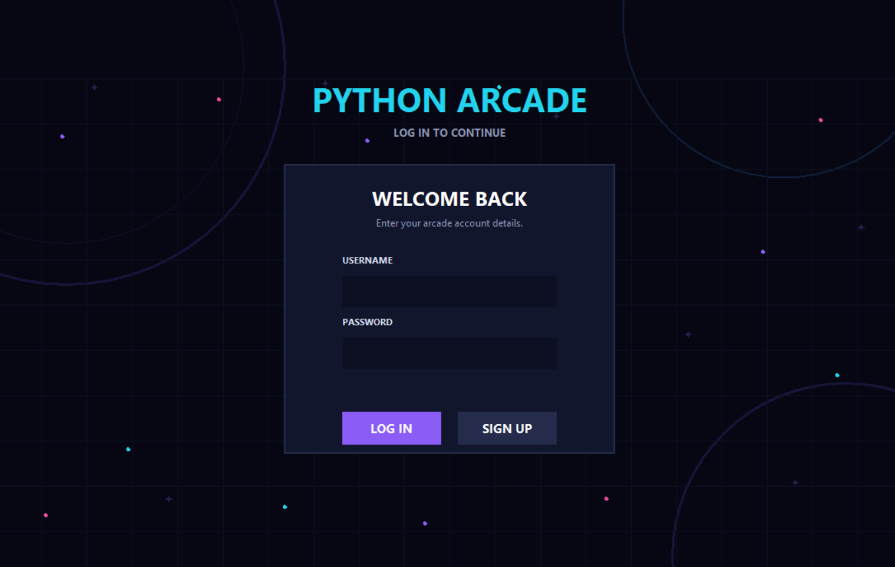

OUTPUT 2 — HOME PAGE

8.2 Home Page
The Home page is the main interface of Python Arcade. It provides navigation to the different sections of the application and displays the player's XP and level.
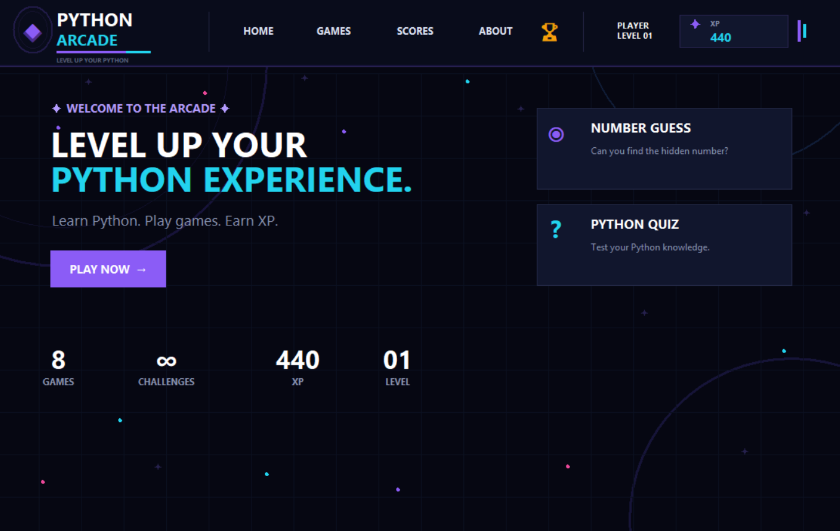

OUTPUT 3 — GAMES PAGE

8.3 Games Page
The Games page displays the eight games available in Python Arcade. Players can select any game and start playing.
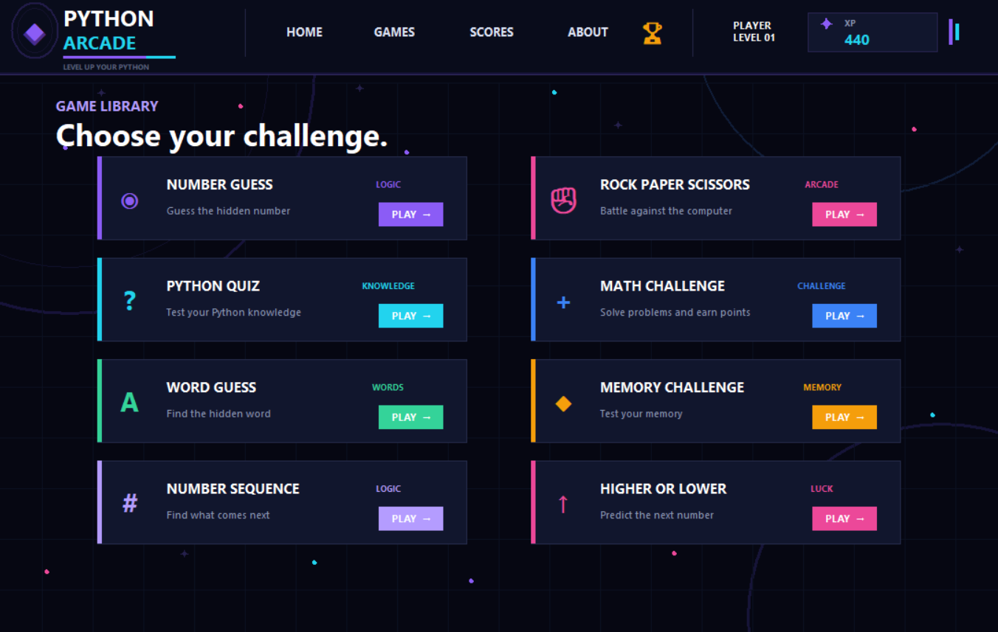

OUTPUT 4 — GAME IN PROGRESS

8.4 Game in Progress
This screen shows one of the games while it is being played. The player interacts with the game controls and receives immediate feedback.
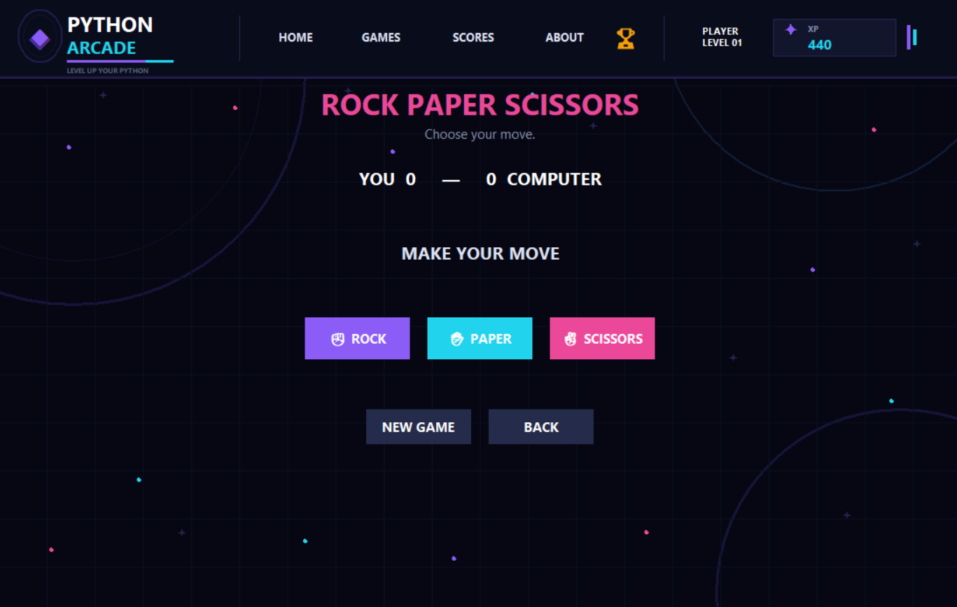

OUTPUT 5 — GAME RESULT

8.5 Game Result
This screen displays the result after completing a game. It shows the player's score and XP earned.
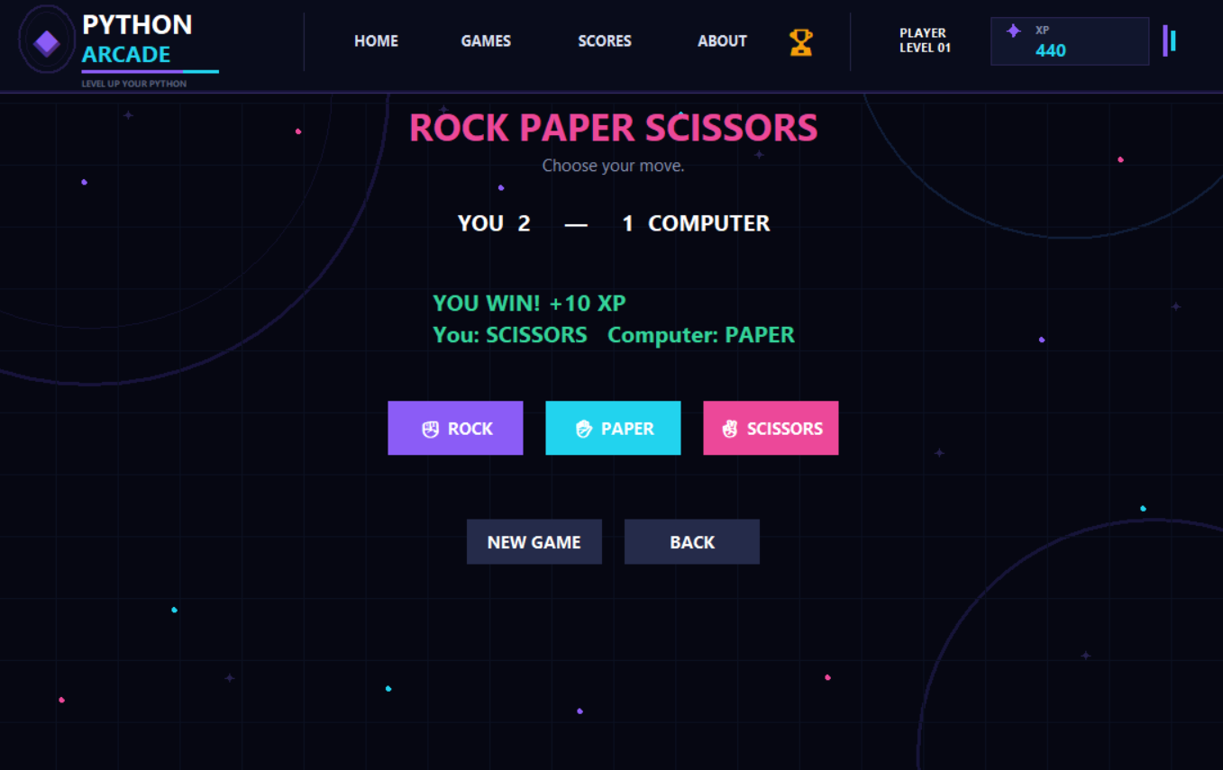

OUTPUT 6 — PLAYER PROFILE

8.6 Player Statistics
The Player Profile displays the player's progress and statistics, including level, XP, games played, games won, games lost, XP earned, recently played game, and achievement progress.
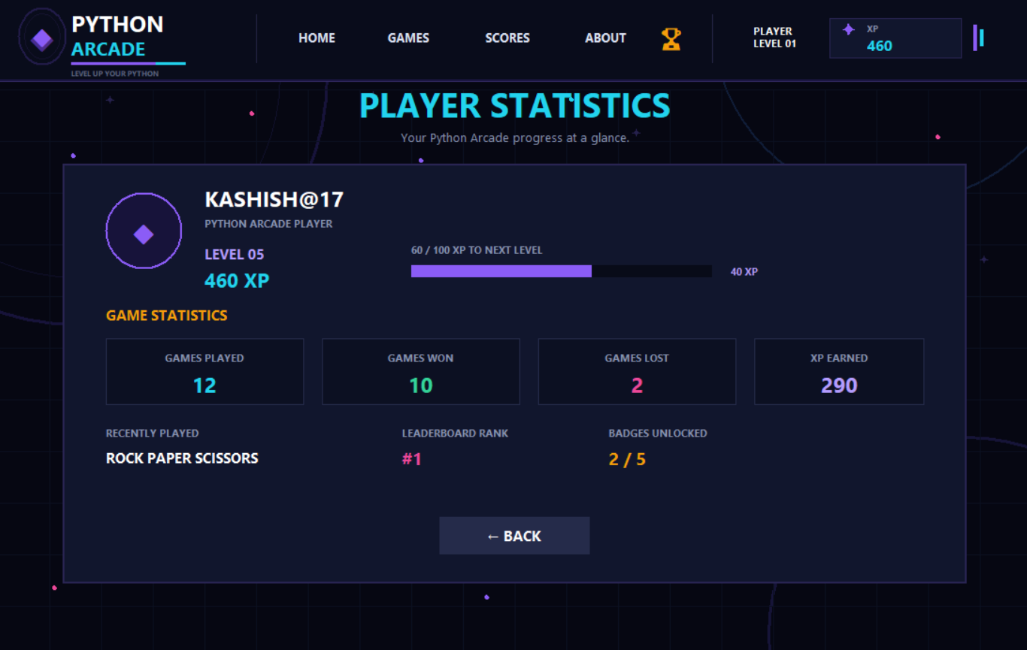

OUTPUT 7 — ACHIEVEMENTS

8.7 Achievements
The Achievements page displays the milestones available to the player. Achievements become unlocked when the player reaches the required XP.
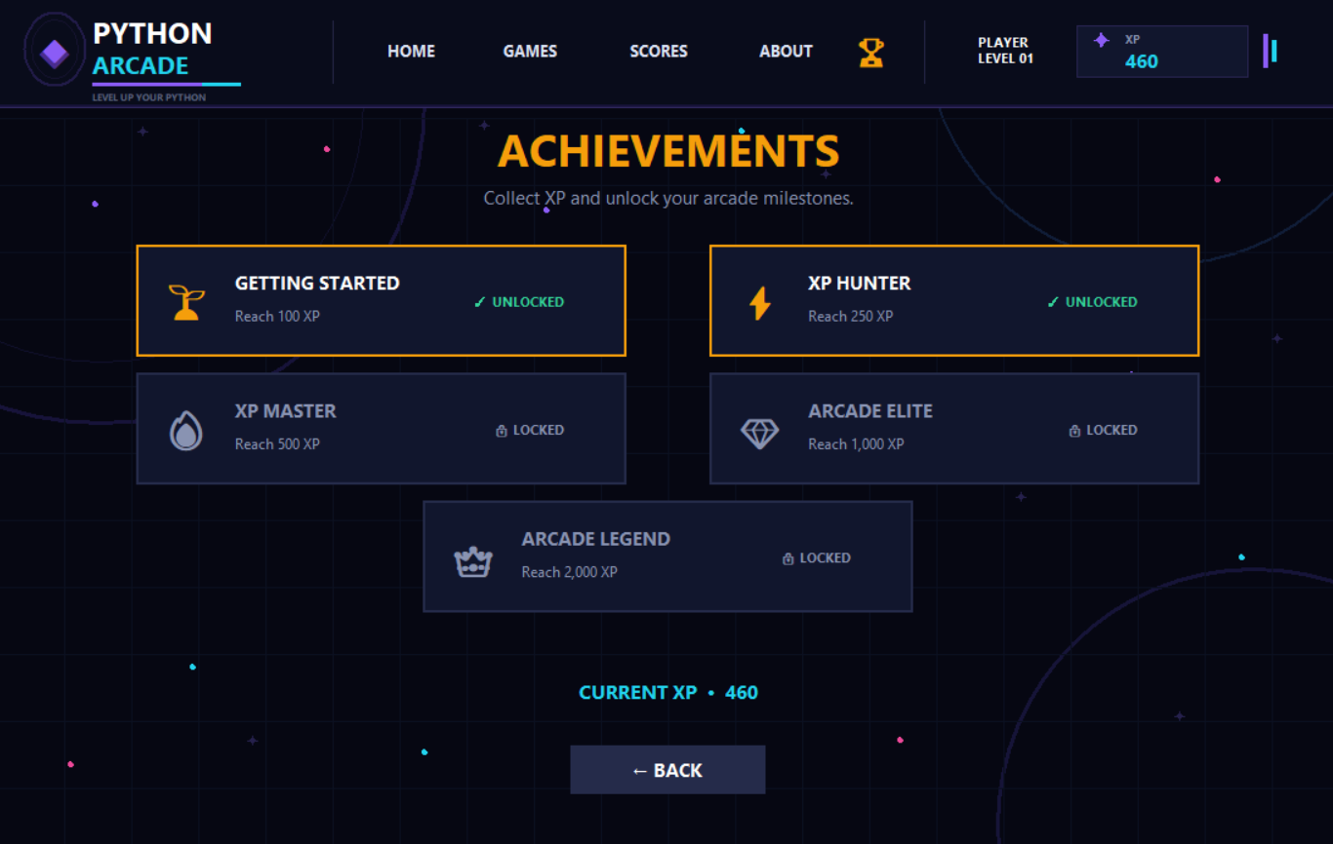

OUTPUT 8 — SCORES / LEADERBOARD

8.8 Scores and Leaderboard
The Scores page displays player scores and the leaderboard. Players are ranked according to their accumulated XP.
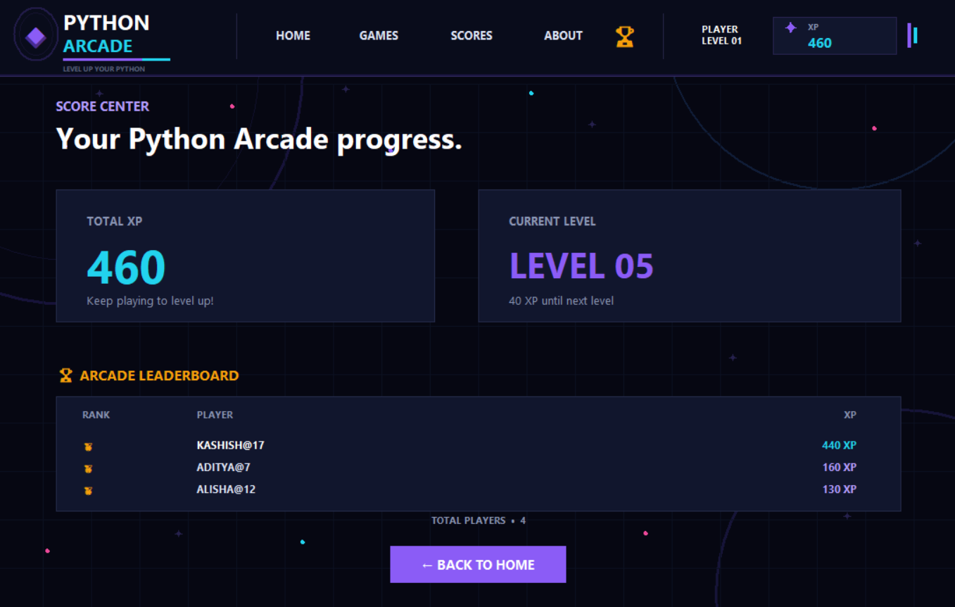

LAST PAGE — CONCLUSION

9. Conclusion
Python Arcade successfully demonstrates how Python can be used to develop an interactive desktop application. The project combines eight different games with a graphical user interface, player accounts, XP, levels, achievements, statistics, and a leaderboard.
Through this project, various Python concepts such as variables, conditional statements, loops, functions, lists, random number generation, Tkinter GUI programming, and file handling were applied in a practical way.
The project provided valuable experience in designing an application, implementing game logic, handling user interaction, and organizing multiple features into one complete Python application.

Acknowledgement
I would like to express my sincere gratitude to my faculty, Rashmi Subodh Chavan, for providing guidance and support throughout the development of this Python project.
I would also like to thank Pillai University for providing the opportunity to work on this project and apply the concepts learned in Python programming to a practical application.
Finally, I would like to thank everyone who supported and encouraged me during the development and testing of Python Arcade.

